**ПР 01.**

**Задание 1.**

Найти длину окружности L и площадь круга S заданного радиуса R:

$L=2∙π∙R, S= π∙R^{2}$

**Листинг интерфейса.**

﻿<Window x:Class="kochergin_225_1.MainWindow"

xmlns="http://schemas.microsoft.com/winfx/2006/xaml/presentation"

xmlns:x="http://schemas.microsoft.com/winfx/2006/xaml"

xmlns:d="http://schemas.microsoft.com/expression/blend/2008"

xmlns:mc="http://schemas.openxmlformats.org/markup-compatibility/2006"

xmlns:local="clr-namespace:kochergin_225_1"

mc:Ignorable="d"

Title="Задание 1" Height="450" Width="800"

Icon="/Icons/1.ico"

>

<Window.Resources>

<Style TargetType="Control" x:Key="Graphic Element">

<Setter Property="Height" Value="42" />

<Setter Property="Margin" Value="16" />

<Setter Property="Padding" Value="12" />

</Style>

<Style TargetType="Label" x:Key="Text" BasedOn="{StaticResource Graphic Element}">

<Setter Property="FontSize" Value="14" />

<Setter Property="FontFamily" Value="Candana" />

</Style>

<Style x:Key="Main Text" TargetType="Label" BasedOn="{StaticResource Text}">

<Setter Property="Foreground" Value="#243238"/>

</Style>

<Style x:Key="Sub Text" TargetType="Label" BasedOn="{StaticResource Text}">

<Setter Property="Foreground" Value="#78909c"/>

</Style>

<Style x:Key="Attention Text" TargetType="Label" BasedOn="{StaticResource Text}">

<Setter Property="Foreground" Value="#fff6a5"/>

</Style>

</Window.Resources>

<Grid>

<Grid.RowDefinitions>

<RowDefinition></RowDefinition>

<RowDefinition></RowDefinition>

<RowDefinition></RowDefinition>

<RowDefinition></RowDefinition>

</Grid.RowDefinitions>

<Grid.ColumnDefinitions>

<ColumnDefinition></ColumnDefinition>

<ColumnDefinition></ColumnDefinition>

<ColumnDefinition></ColumnDefinition>

<ColumnDefinition></ColumnDefinition>

</Grid.ColumnDefinitions>

<StackPanel Grid.Row="1" Grid.Column="1" Grid.ColumnSpan="2" Orientation="Horizontal" HorizontalAlignment="Center" VerticalAlignment="Center">

<Label Content="Введите R: " Style="{StaticResource Main Text}"></Label>

<TextBox x:Name="R" BorderThickness="1" Width="100" BorderBrush="Black" Style="{StaticResource Graphic Element}" TextChanged="R_TextChanged"></TextBox>

</StackPanel>

<StackPanel Grid.Row="2" Grid.Column="1" Grid.ColumnSpan="2" Grid.RowSpan="2" Orientation="Vertical" HorizontalAlignment="Center" VerticalAlignment="Center">

<StackPanel Orientation="Horizontal" HorizontalAlignment="Center" VerticalAlignment="Center">

<Label Content="L: " Style="{StaticResource Sub Text}"></Label>

<Label x:Name="L" Style="{StaticResource Main Text}">-</Label>

</StackPanel>

<StackPanel Orientation="Horizontal" HorizontalAlignment="Center" VerticalAlignment="Center">

<Label Content="S: " Style="{StaticResource Sub Text}"></Label>

<Label x:Name="S" Style="{StaticResource Main Text}">-</Label>

</StackPanel>

</StackPanel>

</Grid>

</Window>

**Листинг программы.**

**﻿**using System;

using System.Collections.Generic;

using System.Linq;

using System.Text;

using System.Threading.Tasks;

using System.Windows;

using System.Windows.Controls;

using System.Windows.Data;

using System.Windows.Documents;

using System.Windows.Input;

using System.Windows.Media;

using System.Windows.Media.Imaging;

using System.Windows.Navigation;

using System.Windows.Shapes;

namespace kochergin_225_1

{

/// <summary>

/// Логика взаимодействия для MainWindow.xaml

/// </summary>

public partial class MainWindow : Window

{

public MainWindow()

{

InitializeComponent();

}

private void R_TextChanged(object sender, TextChangedEventArgs e)

{

double l, s = 0.0;

try

{

double r = double.Parse(R.Text);

l = 2 * 3.14 * r;

s = 3.14 * Math.Pow(r, 2);

L.Content = $"{l}";

S.Content = $"{s}";

}

catch (Exception)

{

L.Content = "-";

S.Content = "-";

}

}

}

}

**Скриншот программы**

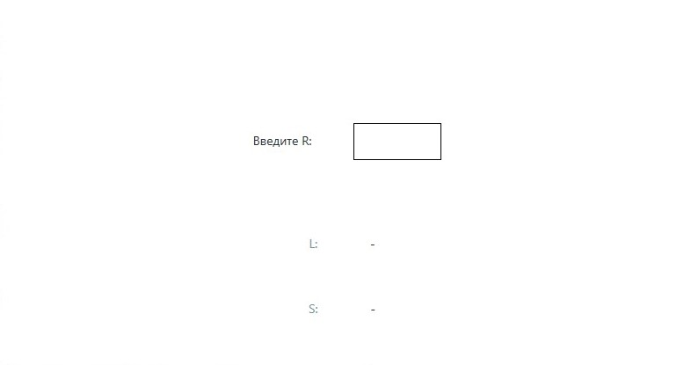

**Задание 2.**

Найти расстояние между двумя точками с заданными координатами

${(x}_{1}, y_{1})$ и ${(x}_{2}, y_{2})$ на плоскости. Расстояние вычисляется по формуле $\sqrt{{(x_{2}-x_{1})}^{2}+{(y_{2}- y_{1})}^{2}}$

**Листинг интерфейса.**

<Window x:Class="_2.MainWindow"

xmlns="http://schemas.microsoft.com/winfx/2006/xaml/presentation"

xmlns:x="http://schemas.microsoft.com/winfx/2006/xaml"

xmlns:d="http://schemas.microsoft.com/expression/blend/2008"

xmlns:mc="http://schemas.openxmlformats.org/markup-compatibility/2006"

xmlns:local="clr-namespace:_2"

mc:Ignorable="d"

Title="Задание 2" Height="450" Width="800"

Icon="/Icons/2.ico">

<Window.Resources>

<Style TargetType="Control" x:Key="Graphic Element">

<Setter Property="Height" Value="42" />

<Setter Property="Margin" Value="16" />

<Setter Property="Padding" Value="12" />

</Style>

<Style TargetType="Label" x:Key="Text" BasedOn="{StaticResource Graphic Element}">

<Setter Property="FontSize" Value="14" />

<Setter Property="FontFamily" Value="Candana" />

</Style>

<Style x:Key="Main Text" TargetType="Label" BasedOn="{StaticResource Text}">

<Setter Property="Foreground" Value="#243238"/>

</Style>

<Style x:Key="Sub Text" TargetType="Label" BasedOn="{StaticResource Text}">

<Setter Property="Foreground" Value="#78909c"/>

</Style>

<Style x:Key="Attention Text" TargetType="Label" BasedOn="{StaticResource Text}">

<Setter Property="Foreground" Value="#fff6a5"/>

</Style>

</Window.Resources>

<Grid>

<Grid.RowDefinitions>

<RowDefinition></RowDefinition>

<RowDefinition></RowDefinition>

<RowDefinition></RowDefinition>

<RowDefinition></RowDefinition>

</Grid.RowDefinitions>

<Grid.ColumnDefinitions>

<ColumnDefinition></ColumnDefinition>

<ColumnDefinition></ColumnDefinition>

<ColumnDefinition></ColumnDefinition>

<ColumnDefinition></ColumnDefinition>

</Grid.ColumnDefinitions>

<StackPanel Grid.Row="0" Grid.Column="0" Grid.ColumnSpan="2" Orientation="Horizontal" HorizontalAlignment="Center" VerticalAlignment="Center">

<Label Content="Введите x₁: " Style="{StaticResource Main Text}"></Label>

<TextBox x:Name="X1" BorderThickness="1" Width="100" BorderBrush="Black" Style="{StaticResource Graphic Element}" TextChanged="X1_TextChanged"></TextBox>

</StackPanel>

<StackPanel Grid.Row="0" Grid.Column="2" Grid.ColumnSpan="2" Orientation="Horizontal" HorizontalAlignment="Center" VerticalAlignment="Center">

<Label Content="Введите y₁: " Style="{StaticResource Main Text}"></Label>

<TextBox x:Name="Y1" BorderThickness="1" Width="100" BorderBrush="Black" Style="{StaticResource Graphic Element}" TextChanged="Y1_TextChanged"></TextBox>

</StackPanel>

<StackPanel Grid.Row="1" Grid.Column="0" Grid.ColumnSpan="2" Orientation="Horizontal" HorizontalAlignment="Center" VerticalAlignment="Center">

<Label Content="Введите x₂: " Style="{StaticResource Main Text}"></Label>

<TextBox x:Name="X2" BorderThickness="1" Width="100" BorderBrush="Black" Style="{StaticResource Graphic Element}" TextChanged="X2_TextChanged"></TextBox>

</StackPanel>

<StackPanel Grid.Row="1" Grid.Column="2" Grid.ColumnSpan="2" Orientation="Horizontal" HorizontalAlignment="Center" VerticalAlignment="Center">

<Label Content="Введите y₂: " Style="{StaticResource Main Text}"></Label>

<TextBox x:Name="Y2" BorderThickness="1" Width="100" BorderBrush="Black" Style="{StaticResource Graphic Element}" TextChanged="Y2_TextChanged"></TextBox>

</StackPanel>

<StackPanel Grid.Row="2" Grid.Column="1" Grid.ColumnSpan="2" Grid.RowSpan="2" Orientation="Vertical" HorizontalAlignment="Center" VerticalAlignment="Center">

<StackPanel Orientation="Horizontal" HorizontalAlignment="Center" VerticalAlignment="Center">

<Label Content="Расстояние:" Style="{StaticResource Sub Text}"></Label>

<Label x:Name="distance" Style="{StaticResource Main Text}">-</Label>

</StackPanel>

</StackPanel>

</Grid>

</Window>

**Листинг программы.**

using System;

using System.Collections.Generic;

using System.Linq;

using System.Text;

using System.Threading.Tasks;

using System.Windows;

using System.Windows.Controls;

using System.Windows.Data;

using System.Windows.Documents;

using System.Windows.Input;

using System.Windows.Media;

using System.Windows.Media.Imaging;

using System.Windows.Navigation;

using System.Windows.Shapes;

namespace _2

{

/// <summary>

/// Логика взаимодействия для MainWindow.xaml

/// </summary>

public partial class MainWindow : Window

{

public MainWindow()

{

InitializeComponent();

}

double x1, x2, y1, y2;

private void X1_TextChanged(object sender, TextChangedEventArgs e)

{

try

{

x1 = double.Parse(X1.Text);

x2 = double.Parse(X2.Text);

y1 = double.Parse(Y1.Text);

y2 = double.Parse(Y2.Text);

double distance_ = Math.Sqrt(Math.Pow(x2 - x1, 2) + Math.Pow(y2 - y1, 2));

distance.Content = $"{distance_}";

}

catch (Exception) { };

}

private void Y1_TextChanged(object sender, TextChangedEventArgs e)

{

try

{

x1 = double.Parse(X1.Text);

x2 = double.Parse(X2.Text);

y1 = double.Parse(Y1.Text);

y2 = double.Parse(Y2.Text);

double distance_ = Math.Sqrt(Math.Pow(x2 - x1, 2) + Math.Pow(y2 - y1, 2));

distance.Content = $"{distance_}";

}

catch (Exception) { };

}

private void X2_TextChanged(object sender, TextChangedEventArgs e)

{

try

{

x1 = double.Parse(X1.Text);

x2 = double.Parse(X2.Text);

y1 = double.Parse(Y1.Text);

y2 = double.Parse(Y2.Text);

double distance_ = Math.Sqrt(Math.Pow(x2 - x1, 2) + Math.Pow(y2 - y1, 2));

distance.Content = $"{distance_}";

}

catch (Exception) { };

}

private void Y2_TextChanged(object sender, TextChangedEventArgs e)

{

try

{

x1 = double.Parse(X1.Text);

x2 = double.Parse(X2.Text);

y1 = double.Parse(Y1.Text);

y2 = double.Parse(Y2.Text);

double distance_ = Math.Sqrt(Math.Pow(x2 - x1, 2) + Math.Pow(y2 - y1, 2));

distance.Content = $"{distance_}";

}

catch (Exception) { };

}

}

}

**Скриншот программы.**

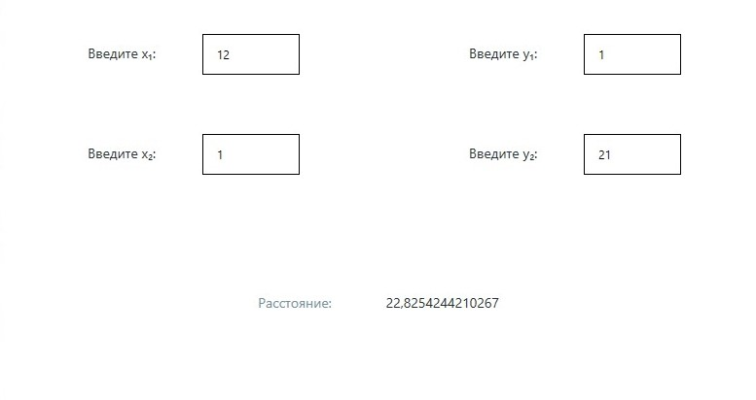

**Задание 3**

Известно, что X кг конфет стоит A рублей. Определить, сколько стоит

1 кг и Y кг этих же конфет.

**Листинг интерфейса.**

<Window x:Class="_3.MainWindow"

xmlns="http://schemas.microsoft.com/winfx/2006/xaml/presentation"

xmlns:x="http://schemas.microsoft.com/winfx/2006/xaml"

xmlns:d="http://schemas.microsoft.com/expression/blend/2008"

xmlns:mc="http://schemas.openxmlformats.org/markup-compatibility/2006"

xmlns:local="clr-namespace:_3"

mc:Ignorable="d"

Title="Задание 3" Height="450" Width="800"

Icon="/Icons/3.ico">

<Window.Resources>

<Style TargetType="Control" x:Key="Graphic Element">

<Setter Property="Height" Value="42" />

<Setter Property="Margin" Value="16" />

<Setter Property="Padding" Value="12" />

</Style>

<Style TargetType="Label" x:Key="Text" BasedOn="{StaticResource Graphic Element}">

<Setter Property="FontSize" Value="14" />

<Setter Property="FontFamily" Value="Candana" />

</Style>

<Style x:Key="Main Text" TargetType="Label" BasedOn="{StaticResource Text}">

<Setter Property="Foreground" Value="#243238"/>

</Style>

<Style x:Key="Sub Text" TargetType="Label" BasedOn="{StaticResource Text}">

<Setter Property="Foreground" Value="#78909c"/>

</Style>

<Style x:Key="Attention Text" TargetType="Label" BasedOn="{StaticResource Text}">

<Setter Property="Foreground" Value="#fff6a5"/>

</Style>

</Window.Resources>

<Grid>

<Grid.RowDefinitions>

<RowDefinition></RowDefinition>

<RowDefinition></RowDefinition>

<RowDefinition></RowDefinition>

</Grid.RowDefinitions>

<Grid.ColumnDefinitions>

<ColumnDefinition></ColumnDefinition>

<ColumnDefinition></ColumnDefinition>

</Grid.ColumnDefinitions>

<StackPanel Grid.Row="0" Grid.Column="0" Orientation="Horizontal" HorizontalAlignment="Center" VerticalAlignment="Center">

<Label Content="Конфет (X): " Style="{StaticResource Main Text}"></Label>

<TextBox x:Name="X" BorderThickness="1" Width="100" BorderBrush="Black" Style="{StaticResource Graphic Element}" TextChanged="X_TextChanged"></TextBox>

</StackPanel>

<StackPanel Grid.Row="1" Grid.Column="0" Orientation="Horizontal" HorizontalAlignment="Center" VerticalAlignment="Center">

<Label Content="Стоимость X конфет (A): " Style="{StaticResource Main Text}"></Label>

<TextBox x:Name="A" BorderThickness="1" Width="100" BorderBrush="Black" Style="{StaticResource Graphic Element}" TextChanged="A_TextChanged"></TextBox>

</StackPanel>

<StackPanel Grid.Row="2" Grid.Column="0" Orientation="Horizontal" HorizontalAlignment="Center" VerticalAlignment="Center">

<Label Content="Вычислить для кол-ва (Y): " Style="{StaticResource Main Text}"></Label>

<TextBox x:Name="Y_in" BorderThickness="1" Width="100" BorderBrush="Black" Style="{StaticResource Graphic Element}" TextChanged="Y_in_TextChanged"></TextBox>

</StackPanel>

<StackPanel Grid.Row="0" Grid.Column="1" Grid.RowSpan="2" Orientation="Vertical" HorizontalAlignment="Center" VerticalAlignment="Center">

<StackPanel Orientation="Horizontal" HorizontalAlignment="Center" VerticalAlignment="Center">

<Label Content="1 кг. стоит (руб):" Style="{StaticResource Sub Text}"></Label>

<Label x:Name="One" Style="{StaticResource Main Text}">-</Label>

</StackPanel>

</StackPanel>

<StackPanel Grid.Row="1" Grid.Column="2" Grid.RowSpan="2" Orientation="Vertical" HorizontalAlignment="Center" VerticalAlignment="Center">

<StackPanel Orientation="Horizontal" HorizontalAlignment="Center" VerticalAlignment="Center">

<Label Content="Y кг. стоит (руб):" Style="{StaticResource Sub Text}"></Label>

<Label x:Name="Y_out" Style="{StaticResource Main Text}">-</Label>

</StackPanel>

</StackPanel>

</Grid>

</Window>

**Листинг программы.**

using System;

using System.Collections.Generic;

using System.Linq;

using System.Text;

using System.Threading.Tasks;

using System.Windows;

using System.Windows.Controls;

using System.Windows.Data;

using System.Windows.Documents;

using System.Windows.Input;

using System.Windows.Media;

using System.Windows.Media.Imaging;

using System.Windows.Navigation;

using System.Windows.Shapes;

namespace _3

{

/// <summary>

/// Логика взаимодействия для MainWindow.xaml

/// </summary>

public partial class MainWindow : Window

{

public MainWindow()

{

InitializeComponent();

}

private void A_TextChanged(object sender, TextChangedEventArgs e)

{

try

{

// x кг конфет стоит a руб. Сколько стоит 1 кг конфет и y кг конфет?

// a / x = стоимость за 1 кг. Тогда стоимость за 1 кг * y = стоимость за y кг

double x = double.Parse(X.Text);

double y_in = double.Parse(Y_in.Text);

double a = double.Parse(A.Text);

if (x != 0.0)

{

double one = a / x;

double y_out = one * y_in;

One.Content = $"{one}";

Y_out.Content = $"{y_out}";

}

else

{

One.Content = "неизвестно (т.к. x = 0)";

Y_out.Content = "неизвестно (т.к. x = 0)";

}

}

catch (Exception) { }

}

private void X_TextChanged(object sender, TextChangedEventArgs e)

{

try

{

// x кг конфет стоит a руб. Сколько стоит 1 кг конфет и y кг конфет?

// a / x = стоимость за 1 кг. Тогда стоимость за 1 кг * y = стоимость за y кг

double x = double.Parse(X.Text);

double y_in = double.Parse(Y_in.Text);

double a = double.Parse(A.Text);

if (x != 0.0)

{

double one = a / x;

double y_out = one * y_in;

One.Content = $"{one}";

Y_out.Content = $"{y_out}";

}

else

{

One.Content = "неизвестно (т.к. x = 0)";

Y_out.Content = "неизвестно (т.к. x = 0)";

}

}

catch (Exception) { }

}

private void Y_in_TextChanged(object sender, TextChangedEventArgs e)

{

try

{

// x кг конфет стоит a руб. Сколько стоит 1 кг конфет и y кг конфет?

// a / x = стоимость за 1 кг. Тогда стоимость за 1 кг * y = стоимость за y кг

double x = double.Parse(X.Text);

double y_in = double.Parse(Y_in.Text);

double a = double.Parse(A.Text);

if (x != 0.0)

{

double one = a / x;

double y_out = one * y_in;

One.Content = $"{one}";

Y_out.Content = $"{y_out}";

}

else

{

One.Content = "неизвестно (т.к. x = 0)";

Y_out.Content = "неизвестно (т.к. x = 0)";

}

}

catch (Exception) { }

}

}

}

**Скриншот программы**

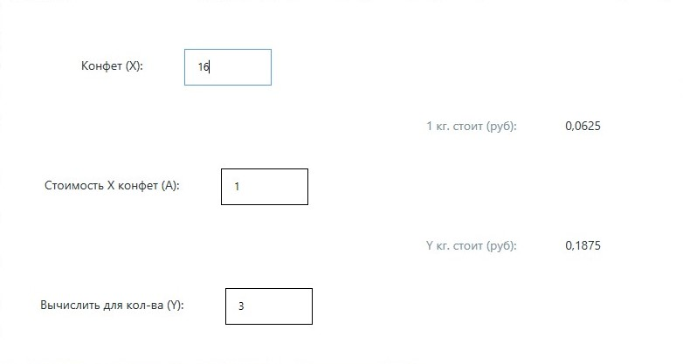

**Задание 4**

Найти значение выражения. Исходные данные необходимо подобрать

самостоятельно, исходя из допустимой области значений исследуемой функции. $a=\frac{1}{cos⁡x}+ln\left|\text{tg}\left(\frac{x}{2}\right)\right|+b^{2}$, где $b={10}^{x+lg⁡(x)}$

**Листинг интерфейса.**

<Window x:Class="_4.MainWindow"

xmlns="http://schemas.microsoft.com/winfx/2006/xaml/presentation"

xmlns:x="http://schemas.microsoft.com/winfx/2006/xaml"

xmlns:d="http://schemas.microsoft.com/expression/blend/2008"

xmlns:mc="http://schemas.openxmlformats.org/markup-compatibility/2006"

xmlns:local="clr-namespace:_4"

mc:Ignorable="d"

Title="Задание 4" Height="450" Width="800"

Icon="/Icons/4.ico">

<Window.Resources>

<Style TargetType="Control" x:Key="Graphic Element">

<Setter Property="Height" Value="42" />

<Setter Property="Margin" Value="16" />

<Setter Property="Padding" Value="12" />

</Style>

<Style TargetType="Label" x:Key="Text" BasedOn="{StaticResource Graphic Element}">

<Setter Property="FontSize" Value="14" />

<Setter Property="FontFamily" Value="Candana" />

</Style>

<Style x:Key="Main Text" TargetType="Label" BasedOn="{StaticResource Text}">

<Setter Property="Foreground" Value="#243238"/>

</Style>

<Style x:Key="Sub Text" TargetType="Label" BasedOn="{StaticResource Text}">

<Setter Property="Foreground" Value="#78909c"/>

</Style>

<Style x:Key="Attention Text" TargetType="Label" BasedOn="{StaticResource Text}">

<Setter Property="Foreground" Value="#fff6a5"/>

</Style>

</Window.Resources>

<Grid>

<Grid.RowDefinitions>

<RowDefinition></RowDefinition>

<RowDefinition></RowDefinition>

<RowDefinition></RowDefinition>

<RowDefinition></RowDefinition>

</Grid.RowDefinitions>

<Grid.ColumnDefinitions>

<ColumnDefinition></ColumnDefinition>

<ColumnDefinition></ColumnDefinition>

<ColumnDefinition></ColumnDefinition>

<ColumnDefinition></ColumnDefinition>

</Grid.ColumnDefinitions>

<StackPanel Grid.Row="1" Grid.Column="1" Grid.ColumnSpan="2" Orientation="Horizontal" HorizontalAlignment="Center" VerticalAlignment="Center">

<Label Content="Введите X: " Style="{StaticResource Main Text}"></Label>

<TextBox x:Name="X" BorderThickness="1" Width="100" BorderBrush="Black" Style="{StaticResource Graphic Element}" TextChanged="X_TextChanged"></TextBox>

</StackPanel>

<StackPanel Grid.Row="2" Grid.Column="1" Grid.ColumnSpan="2" Grid.RowSpan="2" Orientation="Vertical" HorizontalAlignment="Center" VerticalAlignment="Center">

<StackPanel Orientation="Horizontal" HorizontalAlignment="Center" VerticalAlignment="Center">

<Label Content="Тогда a: " Style="{StaticResource Sub Text}"></Label>

<Label x:Name="A" Style="{StaticResource Main Text}">-</Label>

</StackPanel>

</StackPanel>

</Grid>

</Window>

**Листинг программы.**

using System;

using System.Collections.Generic;

using System.Linq;

using System.Text;

using System.Threading.Tasks;

using System.Windows;

using System.Windows.Controls;

using System.Windows.Data;

using System.Windows.Documents;

using System.Windows.Input;

using System.Windows.Media;

using System.Windows.Media.Imaging;

using System.Windows.Navigation;

using System.Windows.Shapes;

namespace _4

{

/// <summary>

/// Логика взаимодействия для MainWindow.xaml

/// </summary>

public partial class MainWindow : Window

{

public MainWindow()

{

InitializeComponent();

}

private void X_TextChanged(object sender, TextChangedEventArgs e)

{

try

{

double x = double.Parse(X.Text);

if (x > 0)

{

double b = Math.Pow(10, x + Math.Log(x));

double a = 1.0 / Math.Cos(x) + Math.Log(Math.Abs(Math.Tan(x / 2))) + Math.Pow(b, 2);

A.Content = $"{a}";

}

else

{

A.Content = "вне области допуст. знач.";

}

}

catch (Exception)

{

A.Content = "-";

}

}

}

}

**Скриншот программы**

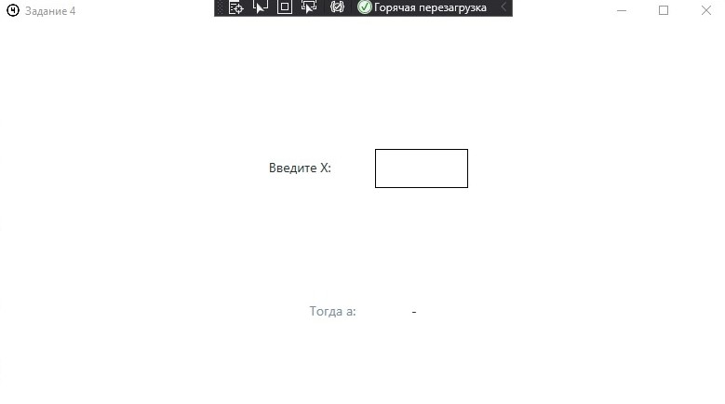

**Задание 5**

Найти решение системы линейных уравнений вида

A1·x + B1·y = C1, A2·x + B2·y = C2,

заданной своими коэффициентами A1, B1, C1, A2, B2, C2, если известно, что

данная система имеет единственное решение.

Воспользоваться формулами

x = (C1·B2 − C2·B1)/D, y = (A1·C2 − A2·C1)/D, где D = A1·B2 − A2·B1.

**Листинг интерфейса.**

<Window x:Class="_5.MainWindow"

xmlns="http://schemas.microsoft.com/winfx/2006/xaml/presentation"

xmlns:x="http://schemas.microsoft.com/winfx/2006/xaml"

xmlns:d="http://schemas.microsoft.com/expression/blend/2008"

xmlns:mc="http://schemas.openxmlformats.org/markup-compatibility/2006"

xmlns:local="clr-namespace:_5"

mc:Ignorable="d"

Title="Задание 5" Height="450" Width="800"

Icon="/Icons/5.ico">

<Window.Resources>

<Style TargetType="Control" x:Key="Graphic Element">

<Setter Property="Height" Value="42" />

<Setter Property="Margin" Value="16" />

<Setter Property="Padding" Value="12" />

</Style>

<Style TargetType="Label" x:Key="Text" BasedOn="{StaticResource Graphic Element}">

<Setter Property="FontSize" Value="14" />

<Setter Property="FontFamily" Value="Candana" />

</Style>

<Style x:Key="Main Text" TargetType="Label" BasedOn="{StaticResource Text}">

<Setter Property="Foreground" Value="#243238"/>

</Style>

<Style x:Key="Sub Text" TargetType="Label" BasedOn="{StaticResource Text}">

<Setter Property="Foreground" Value="#78909c"/>

</Style>

<Style x:Key="Attention Text" TargetType="Label" BasedOn="{StaticResource Text}">

<Setter Property="Foreground" Value="#fff6a5"/>

</Style>

</Window.Resources>

<Grid>

<Grid.RowDefinitions>

<RowDefinition></RowDefinition>

<RowDefinition></RowDefinition>

<RowDefinition></RowDefinition>

</Grid.RowDefinitions>

<Grid.ColumnDefinitions>

<ColumnDefinition></ColumnDefinition>

<ColumnDefinition></ColumnDefinition>

<ColumnDefinition></ColumnDefinition>

</Grid.ColumnDefinitions>

<StackPanel Grid.Row="0" Grid.Column="0" Orientation="Horizontal" HorizontalAlignment="Center" VerticalAlignment="Center">

<Label Content="Введите A₁: " Style="{StaticResource Main Text}"></Label>

<TextBox x:Name="A1" BorderThickness="1" Width="100" BorderBrush="Black" Style="{StaticResource Graphic Element}" TextChanged="A1_TextChanged"></TextBox>

</StackPanel>

<StackPanel Grid.Row="0" Grid.Column="1" Orientation="Horizontal" HorizontalAlignment="Center" VerticalAlignment="Center">

<Label Content="Введите B₁: " Style="{StaticResource Main Text}"></Label>

<TextBox x:Name="B1" BorderThickness="1" Width="100" BorderBrush="Black" Style="{StaticResource Graphic Element}" TextChanged="B1_TextChanged"></TextBox>

</StackPanel>

<StackPanel Grid.Row="0" Grid.Column="2" Orientation="Horizontal" HorizontalAlignment="Center" VerticalAlignment="Center">

<Label Content="Введите C₁: " Style="{StaticResource Main Text}"></Label>

<TextBox x:Name="C1" BorderThickness="1" Width="100" BorderBrush="Black" Style="{StaticResource Graphic Element}" TextChanged="C1_TextChanged"></TextBox>

</StackPanel>

<StackPanel Grid.Row="1" Grid.Column="0" Orientation="Horizontal" HorizontalAlignment="Center" VerticalAlignment="Center">

<Label Content="Введите A₂: " Style="{StaticResource Main Text}"></Label>

<TextBox x:Name="A2" BorderThickness="1" Width="100" BorderBrush="Black" Style="{StaticResource Graphic Element}" TextChanged="A2_TextChanged"></TextBox>

</StackPanel>

<StackPanel Grid.Row="1" Grid.Column="1" Orientation="Horizontal" HorizontalAlignment="Center" VerticalAlignment="Center">

<Label Content="Введите B₂: " Style="{StaticResource Main Text}"></Label>

<TextBox x:Name="B2" BorderThickness="1" Width="100" BorderBrush="Black" Style="{StaticResource Graphic Element}" TextChanged="B2_TextChanged"></TextBox>

</StackPanel>

<StackPanel Grid.Row="1" Grid.Column="2" Orientation="Horizontal" HorizontalAlignment="Center" VerticalAlignment="Center">

<Label Content="Введите C₂: " Style="{StaticResource Main Text}"></Label>

<TextBox x:Name="C2" BorderThickness="1" Width="100" BorderBrush="Black" Style="{StaticResource Graphic Element}" TextChanged="C2_TextChanged"></TextBox>

</StackPanel>

<StackPanel Grid.Row="3" Grid.Column="0" Grid.ColumnSpan="2" Orientation="Vertical" HorizontalAlignment="Center" VerticalAlignment="Center">

<StackPanel Orientation="Horizontal" HorizontalAlignment="Center" VerticalAlignment="Center">

<Label Content="Тогда x:" Style="{StaticResource Sub Text}"></Label>

<Label x:Name="X" Style="{StaticResource Main Text}">-</Label>

</StackPanel>

</StackPanel>

<StackPanel Grid.Row="3" Grid.Column="1" Grid.ColumnSpan="2" Orientation="Vertical" HorizontalAlignment="Center" VerticalAlignment="Center">

<StackPanel Orientation="Horizontal" HorizontalAlignment="Center" VerticalAlignment="Center">

<Label Content="Тогда y:" Style="{StaticResource Sub Text}"></Label>

<Label x:Name="Y" Style="{StaticResource Main Text}">-</Label>

</StackPanel>

</StackPanel>

</Grid>

</Window>

**Листинг программы.**

using System;

using System.Collections.Generic;

using System.Linq;

using System.Text;

using System.Threading.Tasks;

using System.Windows;

using System.Windows.Controls;

using System.Windows.Data;

using System.Windows.Documents;

using System.Windows.Input;

using System.Windows.Media;

using System.Windows.Media.Imaging;

using System.Windows.Navigation;

using System.Windows.Shapes;

namespace _5

{

/// <summary>

/// Логика взаимодействия для MainWindow.xaml

/// </summary>

public partial class MainWindow : Window

{

public MainWindow()

{

InitializeComponent();

}

private void compute()

{

try

{

double a1 = double.Parse(A1.Text);

double a2 = double.Parse(A2.Text);

double b1 = double.Parse(B1.Text);

double b2 = double.Parse(B2.Text);

double c1 = double.Parse(C1.Text);

double c2 = double.Parse(C2.Text);

if (a1 * b2 == a2 * b1)

{

X.Content = "не сущ. или не единств.";

Y.Content = "не сущ. или не единств.";

}

else

{

double D = a1 * b2 - a2 * b1;

double x = (c1 * b2 - c2 * b1) / D;

double y = (a1 * c2 - a2 * c1) / D;

X.Content = $"{x}";

Y.Content = $"{y}";

}

}

catch (Exception)

{

X.Content = "-";

Y.Content = "-";

}

}

private void A1_TextChanged(object sender, TextChangedEventArgs e)

{

compute();

}

private void A2_TextChanged(object sender, TextChangedEventArgs e)

{

compute();

}

private void B1_TextChanged(object sender, TextChangedEventArgs e)

{

compute();

}

private void B2_TextChanged(object sender, TextChangedEventArgs e)

{

compute();

}

private void C1_TextChanged(object sender, TextChangedEventArgs e)

{

compute();

}

private void C2_TextChanged(object sender, TextChangedEventArgs e)

{

compute();

}

}

}

**Скриншот программы**

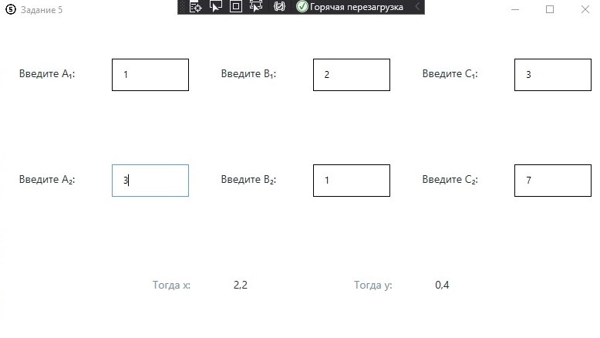

**ПР 02.**

**Задание 1**

Дано двузначное число. Найти сумму и произведение его цифр.

**Листинг интерфейса.**

<Window x:Class="kochergin_225_2.MainWindow"

xmlns="http://schemas.microsoft.com/winfx/2006/xaml/presentation"

xmlns:x="http://schemas.microsoft.com/winfx/2006/xaml"

xmlns:d="http://schemas.microsoft.com/expression/blend/2008"

xmlns:mc="http://schemas.openxmlformats.org/markup-compatibility/2006"

xmlns:local="clr-namespace:kochergin_225_2"

mc:Ignorable="d"

Title="Задание 1" Height="450" Width="800"

Icon="/Icons/1.ico">

<Window.Resources>

<Style TargetType="Control" x:Key="Graphic Element">

<Setter Property="Height" Value="42" />

<Setter Property="Margin" Value="16" />

<Setter Property="Padding" Value="12" />

</Style>

<Style TargetType="Label" x:Key="Text" BasedOn="{StaticResource Graphic Element}">

<Setter Property="FontSize" Value="14" />

<Setter Property="FontFamily" Value="Candana" />

</Style>

<Style x:Key="Main Text" TargetType="Label" BasedOn="{StaticResource Text}">

<Setter Property="Foreground" Value="#243238"/>

</Style>

<Style x:Key="Sub Text" TargetType="Label" BasedOn="{StaticResource Text}">

<Setter Property="Foreground" Value="#78909c"/>

</Style>

<Style x:Key="Attention Text" TargetType="Label" BasedOn="{StaticResource Text}">

<Setter Property="Foreground" Value="#fff6a5"/>

</Style>

<Style x:Key="TextBox" TargetType="TextBox" BasedOn="{StaticResource Graphic Element}">

<Setter Property="BorderBrush" Value="#243238"/>

<Setter Property="BorderThickness" Value="1"/>

<Setter Property="Foreground" Value="#243238"/>

<Setter Property="Width" Value="100"/>

<Setter Property="TextAlignment" Value="Center"/>

</Style>

</Window.Resources>

<Grid>

<Grid.RowDefinitions>

<RowDefinition></RowDefinition>

<RowDefinition></RowDefinition>

<RowDefinition></RowDefinition>

<RowDefinition></RowDefinition>

</Grid.RowDefinitions>

<Grid.ColumnDefinitions>

<ColumnDefinition></ColumnDefinition>

</Grid.ColumnDefinitions>

<StackPanel Grid.Row="0" Grid.RowSpan="2" Orientation="Horizontal" HorizontalAlignment="Center" VerticalAlignment="Center">

<Label Content="Введите двухзначное число: " Style="{StaticResource Main Text}"></Label>

<TextBox x:Name="Number" Style="{StaticResource TextBox}" TextChanged="Number_TextChanged" MaxLength="2"></TextBox>

</StackPanel>

<StackPanel Grid.Row="1" Grid.RowSpan="3" Orientation="Vertical" HorizontalAlignment="Center" VerticalAlignment="Center">

<StackPanel Orientation="Horizontal" HorizontalAlignment="Center" VerticalAlignment="Center">

<Label Content="Cумма цифр:" Style="{StaticResource Sub Text}"></Label>

<Label x:Name="Sum" Style="{StaticResource Main Text}">-</Label>

</StackPanel>

<StackPanel Orientation="Horizontal" HorizontalAlignment="Center" VerticalAlignment="Center">

<Label Content="Произведение цифр:" Style="{StaticResource Sub Text}"></Label>

<Label x:Name="Product" Style="{StaticResource Main Text}">-</Label>

</StackPanel>

</StackPanel>

</Grid>

</Window>

**Листинг программы.**

using System;

using System.Collections.Generic;

using System.Linq;

using System.Text;

using System.Threading.Tasks;

using System.Windows;

using System.Windows.Controls;

using System.Windows.Data;

using System.Windows.Documents;

using System.Windows.Input;

using System.Windows.Media;

using System.Windows.Media.Imaging;

using System.Windows.Navigation;

using System.Windows.Shapes;

namespace kochergin_225_2

{

/// <summary>

/// Логика взаимодействия для MainWindow.xaml

/// </summary>

public partial class MainWindow : Window

{

public MainWindow()

{

InitializeComponent();

}

private void Number_TextChanged(object sender, TextChangedEventArgs e)

{

try

{

double digit_1 = double.Parse($"{Number.Text[0]}");

double digit_2 = double.Parse($"{Number.Text[1]}");

Sum.Content = $"{digit_1 + digit_2}";

Product.Content = $"{digit_1 * digit_2}";

}

catch

{

Sum.Content = "-";

Product.Content = "-";

}

}

}

}

**Скриншот программы**

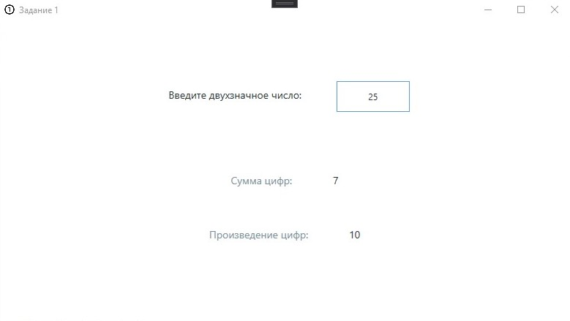

**Задание 2**

С начала суток прошло N секунд (N — целое). Найти количество

полных часов, прошедших с начала суток.

**Листинг интерфейса.**

<Window x:Class="_2.MainWindow"

xmlns="http://schemas.microsoft.com/winfx/2006/xaml/presentation"

xmlns:x="http://schemas.microsoft.com/winfx/2006/xaml"

xmlns:d="http://schemas.microsoft.com/expression/blend/2008"

xmlns:mc="http://schemas.openxmlformats.org/markup-compatibility/2006"

xmlns:local="clr-namespace:_2"

mc:Ignorable="d"

Title="Задание 2" Height="450" Width="800"

Icon="/Icons/2.ico">

<Window.Resources>

<Style TargetType="Control" x:Key="Graphic Element">

<Setter Property="Height" Value="42" />

<Setter Property="Margin" Value="16" />

<Setter Property="Padding" Value="12" />

</Style>

<Style TargetType="Label" x:Key="Text" BasedOn="{StaticResource Graphic Element}">

<Setter Property="FontSize" Value="14" />

<Setter Property="FontFamily" Value="Candana" />

</Style>

<Style x:Key="Main Text" TargetType="Label" BasedOn="{StaticResource Text}">

<Setter Property="Foreground" Value="#243238"/>

</Style>

<Style x:Key="Sub Text" TargetType="Label" BasedOn="{StaticResource Text}">

<Setter Property="Foreground" Value="#78909c"/>

</Style>

<Style x:Key="Attention Text" TargetType="Label" BasedOn="{StaticResource Text}">

<Setter Property="Foreground" Value="#fff6a5"/>

</Style>

<Style x:Key="TextBox" TargetType="TextBox" BasedOn="{StaticResource Graphic Element}">

<Setter Property="BorderBrush" Value="#243238"/>

<Setter Property="BorderThickness" Value="1"/>

<Setter Property="Foreground" Value="#243238"/>

<Setter Property="Width" Value="100"/>

<Setter Property="TextAlignment" Value="Center"/>

</Style>

</Window.Resources>

<Grid>

<Grid.RowDefinitions>

<RowDefinition></RowDefinition>

<RowDefinition></RowDefinition>

</Grid.RowDefinitions>

<Grid.ColumnDefinitions>

<ColumnDefinition></ColumnDefinition>

</Grid.ColumnDefinitions>

<StackPanel Grid.Row="0" Grid.RowSpan="1" Orientation="Horizontal" HorizontalAlignment="Center" VerticalAlignment="Center">

<Label Content="Введите кол-во секунд: " Style="{StaticResource Main Text}"></Label>

<TextBox x:Name="Seconds" Style="{StaticResource TextBox}" TextChanged="Number_TextChanged"></TextBox>

</StackPanel>

<StackPanel Grid.Row="1" Grid.RowSpan="3" Orientation="Vertical" HorizontalAlignment="Center" VerticalAlignment="Center">

<StackPanel Orientation="Horizontal" HorizontalAlignment="Center" VerticalAlignment="Center">

<Label Content="Полных часов прошло:" Style="{StaticResource Sub Text}"></Label>

<Label x:Name="Hours" Style="{StaticResource Main Text}">-</Label>

</StackPanel>

</StackPanel>

</Grid>

</Window>

**Листинг программы.**

using System;

using System.Collections.Generic;

using System.Linq;

using System.Text;

using System.Threading.Tasks;

using System.Windows;

using System.Windows.Controls;

using System.Windows.Data;

using System.Windows.Documents;

using System.Windows.Input;

using System.Windows.Media;

using System.Windows.Media.Imaging;

using System.Windows.Navigation;

using System.Windows.Shapes;

namespace _2

{

/// <summary>

/// Логика взаимодействия для MainWindow.xaml

/// </summary>

public partial class MainWindow : Window

{

public MainWindow()

{

InitializeComponent();

}

private void Number_TextChanged(object sender, TextChangedEventArgs e)

{

try

{

int seconds = int.Parse($"{Math.Floor(double.Parse(Seconds.Text))}");

int hours = (seconds - seconds % 3600) / 3600;

Hours.Content = $"{hours}";

}

catch

{

Hours.Content = "-";

}

}

}

}

**Скриншот программы**

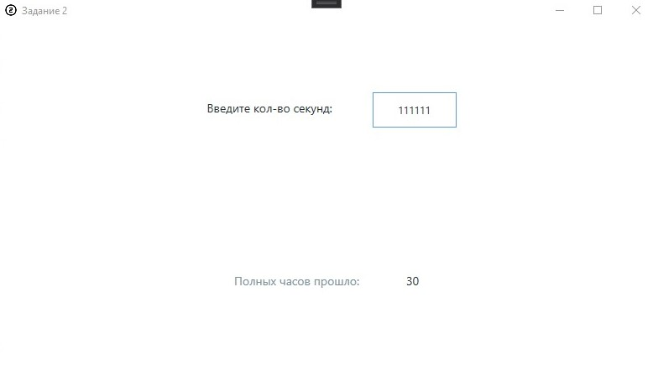

**Задание 3**

Дни недели пронумерованы следующим образом: 0 — воскресенье, 1

— понедельник, 2 — вторник, ..., 6 — суббота. Дано целое число K, лежащее в диапазоне 1–365. Определить номер дня недели для K-го дня года, если известно, что в этом году 1 января было понедельником.

**Листинг интерфейса.**

<Window x:Class="_3.MainWindow"

xmlns="http://schemas.microsoft.com/winfx/2006/xaml/presentation"

xmlns:x="http://schemas.microsoft.com/winfx/2006/xaml"

xmlns:d="http://schemas.microsoft.com/expression/blend/2008"

xmlns:mc="http://schemas.openxmlformats.org/markup-compatibility/2006"

xmlns:local="clr-namespace:_3"

mc:Ignorable="d"

Title="Задание 3" Height="450" Width="800"

Icon="/Icons/3.ico">

<Window.Resources>

<Style TargetType="Control" x:Key="Graphic Element">

<Setter Property="Height" Value="42" />

<Setter Property="Margin" Value="16" />

<Setter Property="Padding" Value="12" />

</Style>

<Style TargetType="Label" x:Key="Text" BasedOn="{StaticResource Graphic Element}">

<Setter Property="FontSize" Value="14" />

<Setter Property="FontFamily" Value="Candana" />

</Style>

<Style x:Key="Main Text" TargetType="Label" BasedOn="{StaticResource Text}">

<Setter Property="Foreground" Value="#243238"/>

</Style>

<Style x:Key="Sub Text" TargetType="Label" BasedOn="{StaticResource Text}">

<Setter Property="Foreground" Value="#78909c"/>

</Style>

<Style x:Key="Attention Text" TargetType="Label" BasedOn="{StaticResource Text}">

<Setter Property="Foreground" Value="#fff6a5"/>

</Style>

<Style x:Key="TextBox" TargetType="TextBox" BasedOn="{StaticResource Graphic Element}">

<Setter Property="BorderBrush" Value="#243238"/>

<Setter Property="BorderThickness" Value="1"/>

<Setter Property="Foreground" Value="#243238"/>

<Setter Property="Width" Value="100"/>

<Setter Property="TextAlignment" Value="Center"/>

</Style>

</Window.Resources>

<Grid>

<Grid.RowDefinitions>

<RowDefinition></RowDefinition>

<RowDefinition></RowDefinition>

</Grid.RowDefinitions>

<Grid.ColumnDefinitions>

<ColumnDefinition></ColumnDefinition>

</Grid.ColumnDefinitions>

<StackPanel Grid.Row="0" Grid.RowSpan="1" Orientation="Horizontal" HorizontalAlignment="Center" VerticalAlignment="Center">

<Label Content="Введите K (день года): " Style="{StaticResource Main Text}"></Label>

<TextBox x:Name="K" Style="{StaticResource TextBox}" TextChanged="K_TextChanged"></TextBox>

</StackPanel>

<StackPanel Grid.Row="1" Grid.RowSpan="3" Orientation="Vertical" HorizontalAlignment="Center" VerticalAlignment="Center">

<StackPanel Orientation="Horizontal" HorizontalAlignment="Center" VerticalAlignment="Center">

<Label Content="Его номер как дня недели:" Style="{StaticResource Sub Text}"></Label>

<Label x:Name="DayOfWeek" Style="{StaticResource Main Text}">-</Label>

</StackPanel>

</StackPanel>

</Grid>

</Window>

**Листинг программы.**

using System;

using System.Collections.Generic;

using System.Linq;

using System.Text;

using System.Threading.Tasks;

using System.Windows;

using System.Windows.Controls;

using System.Windows.Data;

using System.Windows.Documents;

using System.Windows.Input;

using System.Windows.Media;

using System.Windows.Media.Imaging;

using System.Windows.Navigation;

using System.Windows.Shapes;

namespace _3

{

/// <summary>

/// Логика взаимодействия для MainWindow.xaml

/// </summary>

public partial class MainWindow : Window

{

public MainWindow()

{

InitializeComponent();

}

/*

1 янв - 1 день года

1 день года - четверг, тоесть имеет номер 4

2 день года - 5

3 день - 6

4 день - 0

и т.д.

в терминах функции f сопостовления номера дня к дню в аргументе:

f(1) = 4

f(2) = 5

f(3) = 6

f(4) = 0

f(5) = 1

f(6) = 2

f(7) = 3

f(8) = f(1) = 4

...

тоесть функция сопостовления номера к K-ому дню будет:

f(k) = (k + 3) mod 7

*/

private int f(int n)

{

return (n + 3) % 7;

}

private void K_TextChanged(object sender, TextChangedEventArgs e)

{

try

{

int k = int.Parse(K.Text);

if (k < 1 || k > 365)

{

throw new ArgumentOutOfRangeException();

}

DayOfWeek.Content = $"{f(k)}";

}

catch (FormatException)

{

DayOfWeek.Content = "-";

}

catch (ArgumentOutOfRangeException)

{

DayOfWeek.Content = "- (K вне возм. знач.)";

}

catch

{

DayOfWeek.Content = "-";

}

}

}

}

**Скриншот программы**

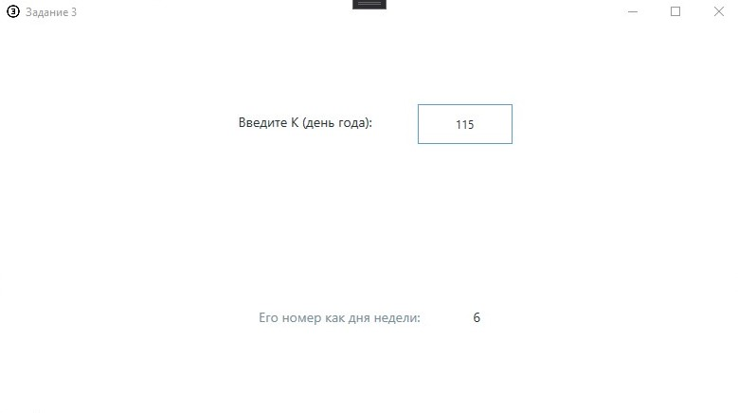

**Задание 4**

Даны целые положительные числа A, B, C. На прямоугольнике размера

A × B размещено максимально возможное количество квадратов со стороной C (без наложений). Найти количество квадратов, размещенных на прямоугольнике, а также площадь незанятой части прямоугольника.

**Листинг интерфейса.**

<Window x:Class="_4.MainWindow"

xmlns="http://schemas.microsoft.com/winfx/2006/xaml/presentation"

xmlns:x="http://schemas.microsoft.com/winfx/2006/xaml"

xmlns:d="http://schemas.microsoft.com/expression/blend/2008"

xmlns:mc="http://schemas.openxmlformats.org/markup-compatibility/2006"

xmlns:local="clr-namespace:_4"

mc:Ignorable="d"

Title="Задание 4" Height="450" Width="800"

Icon="/Icons/4.ico">

<Window.Resources>

<Style TargetType="Control" x:Key="Graphic Element">

<Setter Property="Height" Value="42" />

<Setter Property="Margin" Value="16" />

<Setter Property="Padding" Value="12" />

</Style>

<Style TargetType="Label" x:Key="Text" BasedOn="{StaticResource Graphic Element}">

<Setter Property="FontSize" Value="14" />

<Setter Property="FontFamily" Value="Candana" />

</Style>

<Style x:Key="Main Text" TargetType="Label" BasedOn="{StaticResource Text}">

<Setter Property="Foreground" Value="#243238"/>

</Style>

<Style x:Key="Sub Text" TargetType="Label" BasedOn="{StaticResource Text}">

<Setter Property="Foreground" Value="#78909c"/>

</Style>

<Style x:Key="Attention Text" TargetType="Label" BasedOn="{StaticResource Text}">

<Setter Property="Foreground" Value="#fff6a5"/>

</Style>

<Style x:Key="TextBox" TargetType="TextBox" BasedOn="{StaticResource Graphic Element}">

<Setter Property="BorderBrush" Value="#243238"/>

<Setter Property="BorderThickness" Value="1"/>

<Setter Property="Foreground" Value="#243238"/>

<Setter Property="Width" Value="100"/>

<Setter Property="TextAlignment" Value="Center"/>

</Style>

</Window.Resources>

<Grid>

<Grid.RowDefinitions>

<RowDefinition></RowDefinition>

<RowDefinition></RowDefinition>

<RowDefinition></RowDefinition>

</Grid.RowDefinitions>

<Grid.ColumnDefinitions>

<ColumnDefinition></ColumnDefinition>

<ColumnDefinition></ColumnDefinition>

<ColumnDefinition></ColumnDefinition>

<ColumnDefinition></ColumnDefinition>

</Grid.ColumnDefinitions>

<StackPanel Grid.Row="0" Grid.Column="0" Grid.ColumnSpan="2" Orientation="Horizontal" HorizontalAlignment="Center" VerticalAlignment="Center">

<Label Content="Введите A: " Style="{StaticResource Main Text}"></Label>

<TextBox x:Name="A" Style="{StaticResource TextBox}" TextChanged="A_TextChanged"></TextBox>

</StackPanel>

<StackPanel Grid.Row="1" Grid.Column="0" Grid.ColumnSpan="2" Orientation="Horizontal" HorizontalAlignment="Center" VerticalAlignment="Center">

<Label Content="Введите B: " Style="{StaticResource Main Text}"></Label>

<TextBox x:Name="B" Style="{StaticResource TextBox}" TextChanged="B_TextChanged"></TextBox>

</StackPanel>

<StackPanel Grid.Row="2" Grid.Column="0" Grid.ColumnSpan="2" Orientation="Horizontal" HorizontalAlignment="Center" VerticalAlignment="Center">

<Label Content="Введите C: " Style="{StaticResource Main Text}"></Label>

<TextBox x:Name="C" Style="{StaticResource TextBox}" TextChanged="C_TextChanged"></TextBox>

</StackPanel>

<StackPanel Grid.Row="1" Grid.Column="2" Grid.ColumnSpan="2" Orientation="Vertical" HorizontalAlignment="Center" VerticalAlignment="Center">

<StackPanel Orientation="Horizontal" HorizontalAlignment="Center" VerticalAlignment="Center">

<Label Content="Кол-во квадратов со стороной C:" Style="{StaticResource Sub Text}"></Label>

<Label x:Name="Result" Style="{StaticResource Main Text}">-</Label>

</StackPanel>

</StackPanel>

</Grid>

</Window>

**Листинг программы.**

using System;

using System.Collections.Generic;

using System.Linq;

using System.Text;

using System.Threading.Tasks;

using System.Windows;

using System.Windows.Controls;

using System.Windows.Data;

using System.Windows.Documents;

using System.Windows.Input;

using System.Windows.Media;

using System.Windows.Media.Imaging;

using System.Windows.Navigation;

using System.Windows.Shapes;

namespace _4

{

/// <summary>

/// Логика взаимодействия для MainWindow.xaml

/// </summary>

public partial class MainWindow : Window

{

public MainWindow()

{

InitializeComponent();

}

private void compute()

{

try

{

int a = int.Parse(A.Text);

int b = int.Parse(B.Text);

int c = int.Parse(C.Text);

if (a <= 0 || b <= 0 || c <= 0)

{

throw new ArgumentOutOfRangeException();

}

int m = (a - a % c) / c;

int n = (b - b % c) / c;

Result.Content = $"{n * m}";

}

catch

{

Result.Content = "-";

}

}

private void A_TextChanged(object sender, TextChangedEventArgs e)

{

compute();

}

private void B_TextChanged(object sender, TextChangedEventArgs e)

{

compute();

}

private void C_TextChanged(object sender, TextChangedEventArgs e)

{

compute();

}

}

}

**Скриншот программы**

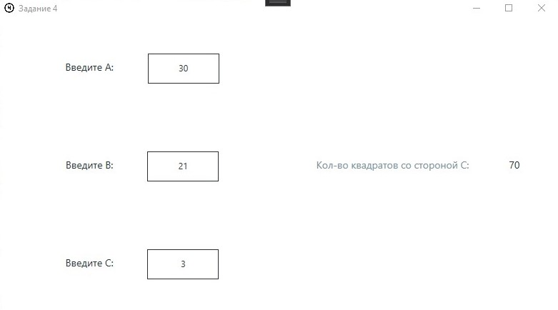

**Задание 5**

Дан номер некоторого года (целое положительное число). Определить

соответствующий ему номер столетия, учитывая, что, к примеру, началом 20 столетия был 1901 год.

**Листинг интерфейса.**

<Window x:Class="_5.MainWindow"

xmlns="http://schemas.microsoft.com/winfx/2006/xaml/presentation"

xmlns:x="http://schemas.microsoft.com/winfx/2006/xaml"

xmlns:d="http://schemas.microsoft.com/expression/blend/2008"

xmlns:mc="http://schemas.openxmlformats.org/markup-compatibility/2006"

xmlns:local="clr-namespace:_5"

mc:Ignorable="d"

Title="Задание 5" Height="450" Width="800"

Icon="/Icons/5.ico">

<Window.Resources>

<Style TargetType="Control" x:Key="Graphic Element">

<Setter Property="Height" Value="42" />

<Setter Property="Margin" Value="16" />

<Setter Property="Padding" Value="12" />

</Style>

<Style TargetType="Label" x:Key="Text" BasedOn="{StaticResource Graphic Element}">

<Setter Property="FontSize" Value="14" />

<Setter Property="FontFamily" Value="Candana" />

</Style>

<Style x:Key="Main Text" TargetType="Label" BasedOn="{StaticResource Text}">

<Setter Property="Foreground" Value="#243238"/>

</Style>

<Style x:Key="Sub Text" TargetType="Label" BasedOn="{StaticResource Text}">

<Setter Property="Foreground" Value="#78909c"/>

</Style>

<Style x:Key="Attention Text" TargetType="Label" BasedOn="{StaticResource Text}">

<Setter Property="Foreground" Value="#fff6a5"/>

</Style>

<Style x:Key="TextBox" TargetType="TextBox" BasedOn="{StaticResource Graphic Element}">

<Setter Property="BorderBrush" Value="#243238"/>

<Setter Property="BorderThickness" Value="1"/>

<Setter Property="Foreground" Value="#243238"/>

<Setter Property="Width" Value="100"/>

<Setter Property="TextAlignment" Value="Center"/>

</Style>

</Window.Resources>

<Grid>

<Grid.RowDefinitions>

<RowDefinition></RowDefinition>

<RowDefinition></RowDefinition>

</Grid.RowDefinitions>

<Grid.ColumnDefinitions>

<ColumnDefinition></ColumnDefinition>

</Grid.ColumnDefinitions>

<StackPanel Grid.Row="0" Grid.Column="0" Orientation="Horizontal" HorizontalAlignment="Center" VerticalAlignment="Center">

<Label Content="Введите год:" Style="{StaticResource Main Text}"></Label>

<TextBox x:Name="Year" Style="{StaticResource TextBox}" TextChanged="Year_TextChanged"></TextBox>

</StackPanel>

<StackPanel Grid.Row="2" Grid.Column="1" Grid.ColumnSpan="2" Grid.RowSpan="2" Orientation="Vertical" HorizontalAlignment="Center" VerticalAlignment="Center">

<StackPanel Orientation="Horizontal" HorizontalAlignment="Center" VerticalAlignment="Center">

<Label Content="Столетие:" Style="{StaticResource Sub Text}"></Label>

<Label x:Name="Century" Style="{StaticResource Main Text}">-</Label>

</StackPanel>

</StackPanel>

</Grid>

</Window>

**Листинг программы.**

using System;

using System.Collections.Generic;

using System.Linq;

using System.Text;

using System.Threading.Tasks;

using System.Windows;

using System.Windows.Controls;

using System.Windows.Data;

using System.Windows.Documents;

using System.Windows.Input;

using System.Windows.Media;

using System.Windows.Media.Imaging;

using System.Windows.Navigation;

using System.Windows.Shapes;

namespace _5

{

/// <summary>

/// Логика взаимодействия для MainWindow.xaml

/// </summary>

public partial class MainWindow : Window

{

public MainWindow()

{

InitializeComponent();

}

private int f(int n)

{

int k = (n - 1 - (n - 1) % 100) / 100;

return 1 + k;

}

private void Year_TextChanged(object sender, TextChangedEventArgs e)

{

try

{

int year = int.Parse(Year.Text);

// в условии целое положительное, тоесть больше нуля

if (year <= 0)

{

throw new IndexOutOfRangeException();

}

int century = f(year);

Century.Content = $"{century}";

}

catch

{

Century.Content = "-";

}

}

}

}

**Скриншот программы**

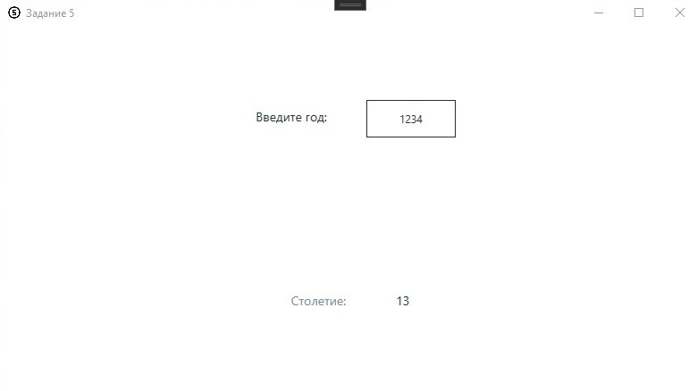

**ПР 03**

**Задание 1**

Является ли сумма цифр двухзначного числа нечетной.

**Листинг интерфейса.**

<Window x:Class="kochergin_225_3.MainWindow"

xmlns="http://schemas.microsoft.com/winfx/2006/xaml/presentation"

xmlns:x="http://schemas.microsoft.com/winfx/2006/xaml"

xmlns:d="http://schemas.microsoft.com/expression/blend/2008"

xmlns:mc="http://schemas.openxmlformats.org/markup-compatibility/2006"

xmlns:local="clr-namespace:kochergin_225_3"

mc:Ignorable="d"

Title="Задание 1" Height="450" Width="800">

<Window.Resources>

<Style TargetType="Control" x:Key="Graphic Element">

<Setter Property="Height" Value="42" />

<Setter Property="Margin" Value="16" />

<Setter Property="Padding" Value="12" />

</Style>

<Style TargetType="Label" x:Key="Text" BasedOn="{StaticResource Graphic Element}">

<Setter Property="FontSize" Value="14" />

<Setter Property="FontFamily" Value="Candana" />

</Style>

<Style x:Key="Main Text" TargetType="Label" BasedOn="{StaticResource Text}">

<Setter Property="Foreground" Value="#243238"/>

</Style>

<Style x:Key="Sub Text" TargetType="Label" BasedOn="{StaticResource Text}">

<Setter Property="Foreground" Value="#78909c"/>

</Style>

<Style x:Key="Attention Text" TargetType="Label" BasedOn="{StaticResource Text}">

<Setter Property="Foreground" Value="#fff6a5"/>

</Style>

<Style x:Key="TextBox" TargetType="TextBox" BasedOn="{StaticResource Graphic Element}">

<Setter Property="BorderBrush" Value="#243238"/>

<Setter Property="BorderThickness" Value="1"/>

<Setter Property="Foreground" Value="#243238"/>

<Setter Property="Width" Value="100"/>

<Setter Property="TextAlignment" Value="Center"/>

</Style>

</Window.Resources>

<Grid>

<Grid.RowDefinitions>

<RowDefinition></RowDefinition>

<RowDefinition></RowDefinition>

<RowDefinition></RowDefinition>

<RowDefinition></RowDefinition>

</Grid.RowDefinitions>

<Grid.ColumnDefinitions>

<ColumnDefinition></ColumnDefinition>

</Grid.ColumnDefinitions>

<StackPanel Grid.Row="0" Grid.RowSpan="2" Orientation="Horizontal" HorizontalAlignment="Center" VerticalAlignment="Center">

<Label Content="Введите двухзначное число: " Style="{StaticResource Main Text}"></Label>

<TextBox x:Name="Number" Style="{StaticResource TextBox}" TextChanged="Number_TextChanged" MaxLength="2"></TextBox>

</StackPanel>

<StackPanel Grid.Row="2" Grid.RowSpan="2" Orientation="Vertical" HorizontalAlignment="Center" VerticalAlignment="Center">

<StackPanel Orientation="Horizontal" HorizontalAlignment="Center" VerticalAlignment="Center">

<Label Content="Cумма цифр:" Style="{StaticResource Sub Text}"></Label>

<Label x:Name="Sum" Style="{StaticResource Main Text}">-</Label>

</StackPanel>

</StackPanel>

</Grid>

</Window>

**Листинг программы.**

using System;

using System.Collections.Generic;

using System.Linq;

using System.Text;

using System.Threading.Tasks;

using System.Windows;

using System.Windows.Controls;

using System.Windows.Data;

using System.Windows.Documents;

using System.Windows.Input;

using System.Windows.Media;

using System.Windows.Media.Imaging;

using System.Windows.Navigation;

using System.Windows.Shapes;

namespace kochergin_225_3

{

/// <summary>

/// Interaction logic for MainWindow.xaml

/// </summary>

public partial class MainWindow : Window

{

public MainWindow()

{

InitializeComponent();

}

private void Number_TextChanged(object sender, TextChangedEventArgs e)

{

try

{

int digit_1 = int.Parse($"{Number.Text[0]}");

int digit_2 = int.Parse($"{Number.Text[1]}");

if ((digit_1 + digit_2) % 2 == 0)

{

Sum.Content = "Чётна";

}

else

{

Sum.Content = "Нечётна";

}

}

catch

{

Sum.Content = "-";

}

}

}

}

**Скриншот программы**

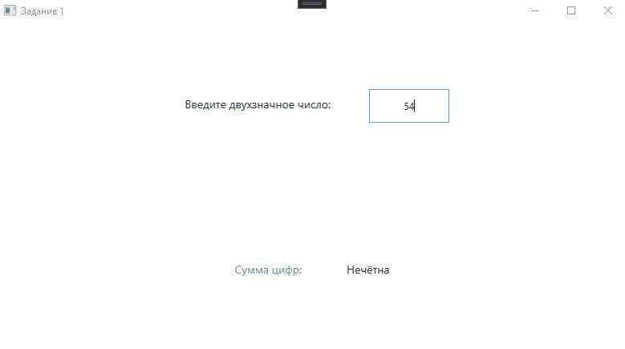

**Задание 2**

Даны два числа. Вывести порядковый номер меньшего из них.

**Листинг интерфейса.**

<Window x:Class="_2.MainWindow"

xmlns="http://schemas.microsoft.com/winfx/2006/xaml/presentation"

xmlns:x="http://schemas.microsoft.com/winfx/2006/xaml"

xmlns:d="http://schemas.microsoft.com/expression/blend/2008"

xmlns:mc="http://schemas.openxmlformats.org/markup-compatibility/2006"

xmlns:local="clr-namespace:_2"

mc:Ignorable="d"

Title="Задание 2" Height="450" Width="800">

<Window.Resources>

<Style TargetType="Control" x:Key="Graphic Element">

<Setter Property="Height" Value="42" />

<Setter Property="Margin" Value="16" />

<Setter Property="Padding" Value="12" />

</Style>

<Style TargetType="Label" x:Key="Text" BasedOn="{StaticResource Graphic Element}">

<Setter Property="FontSize" Value="14" />

<Setter Property="FontFamily" Value="Candana" />

</Style>

<Style x:Key="Main Text" TargetType="Label" BasedOn="{StaticResource Text}">

<Setter Property="Foreground" Value="#243238"/>

</Style>

<Style x:Key="Sub Text" TargetType="Label" BasedOn="{StaticResource Text}">

<Setter Property="Foreground" Value="#78909c"/>

</Style>

<Style x:Key="Attention Text" TargetType="Label" BasedOn="{StaticResource Text}">

<Setter Property="Foreground" Value="#fff6a5"/>

</Style>

<Style x:Key="TextBox" TargetType="TextBox" BasedOn="{StaticResource Graphic Element}">

<Setter Property="BorderBrush" Value="#243238"/>

<Setter Property="BorderThickness" Value="1"/>

<Setter Property="Foreground" Value="#243238"/>

<Setter Property="Width" Value="100"/>

<Setter Property="TextAlignment" Value="Center"/>

</Style>

</Window.Resources>

<Grid>

<Grid.RowDefinitions>

<RowDefinition></RowDefinition>

<RowDefinition></RowDefinition>

</Grid.RowDefinitions>

<Grid.ColumnDefinitions>

<ColumnDefinition></ColumnDefinition>

<ColumnDefinition></ColumnDefinition>

</Grid.ColumnDefinitions>

<StackPanel Grid.Row="0" Grid.Column="0" Orientation="Horizontal" HorizontalAlignment="Center" VerticalAlignment="Center">

<Label Content="Введите первое число: " Style="{StaticResource Main Text}"></Label>

<TextBox x:Name="First" Style="{StaticResource TextBox}" TextChanged="First_TextChanged"></TextBox>

</StackPanel>

<StackPanel Grid.Row="0" Grid.Column="2" Orientation="Horizontal" HorizontalAlignment="Center" VerticalAlignment="Center">

<Label Content="Введите второе число: " Style="{StaticResource Main Text}"></Label>

<TextBox x:Name="Second" Style="{StaticResource TextBox}" TextChanged="Second_TextChanged"></TextBox>

</StackPanel>

<StackPanel Grid.Row="1" Grid.Column="0" Grid.ColumnSpan="2" Grid.RowSpan="2" Orientation="Vertical" HorizontalAlignment="Center" VerticalAlignment="Center">

<StackPanel Orientation="Horizontal" HorizontalAlignment="Center" VerticalAlignment="Center">

<Label Content="Меньшее:" Style="{StaticResource Sub Text}"></Label>

<Label x:Name="Smallest" Style="{StaticResource Main Text}">-</Label>

</StackPanel>

</StackPanel>

</Grid>

</Window>

**Листинг программы.**

using System;

using System.Collections.Generic;

using System.Linq;

using System.Text;

using System.Threading.Tasks;

using System.Windows;

using System.Windows.Controls;

using System.Windows.Data;

using System.Windows.Documents;

using System.Windows.Input;

using System.Windows.Media;

using System.Windows.Media.Imaging;

using System.Windows.Navigation;

using System.Windows.Shapes;

namespace _2

{

/// <summary>

/// Interaction logic for MainWindow.xaml

/// </summary>

public partial class MainWindow : Window

{

public MainWindow()

{

InitializeComponent();

}

private void compute()

{

try

{

double first = double.Parse(First.Text);

double second = double.Parse(Second.Text);

if(first < second)

{

Smallest.Content = $"Первое ({first})";

}

else if(first > second)

{

Smallest.Content = $"Второе ({second})";

}

else

{

Smallest.Content = "Меньшего нет (они равны)";

}

}

catch

{

Smallest.Content = "-";

}

}

private void First_TextChanged(object sender, TextChangedEventArgs e)

{

compute();

}

private void Second_TextChanged(object sender, TextChangedEventArgs e)

{

compute();

}

}

}

**Скриншот программы**

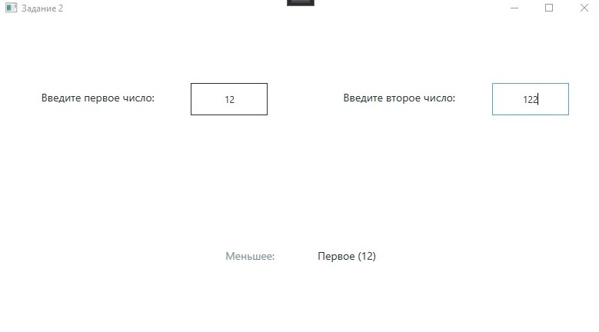

**Задание 3**

Даны три числа. Найти среднее из них (т. е. число, расположенное между

наименьшим и наибольшим).

**Листинг интерфейса.**

<Window x:Class="_3.MainWindow"

xmlns="http://schemas.microsoft.com/winfx/2006/xaml/presentation"

xmlns:x="http://schemas.microsoft.com/winfx/2006/xaml"

xmlns:d="http://schemas.microsoft.com/expression/blend/2008"

xmlns:mc="http://schemas.openxmlformats.org/markup-compatibility/2006"

xmlns:local="clr-namespace:_3"

mc:Ignorable="d"

Title="Задание 3" Height="450" Width="800">

<Window.Resources>

<Style TargetType="Control" x:Key="Graphic Element">

<Setter Property="Height" Value="42" />

<Setter Property="Margin" Value="16" />

<Setter Property="Padding" Value="12" />

</Style>

<Style TargetType="Label" x:Key="Text" BasedOn="{StaticResource Graphic Element}">

<Setter Property="FontSize" Value="14" />

<Setter Property="FontFamily" Value="Candana" />

</Style>

<Style x:Key="Main Text" TargetType="Label" BasedOn="{StaticResource Text}">

<Setter Property="Foreground" Value="#243238"/>

</Style>

<Style x:Key="Sub Text" TargetType="Label" BasedOn="{StaticResource Text}">

<Setter Property="Foreground" Value="#78909c"/>

</Style>

<Style x:Key="Attention Text" TargetType="Label" BasedOn="{StaticResource Text}">

<Setter Property="Foreground" Value="#fff6a5"/>

</Style>

<Style x:Key="TextBox" TargetType="TextBox" BasedOn="{StaticResource Graphic Element}">

<Setter Property="BorderBrush" Value="#243238"/>

<Setter Property="BorderThickness" Value="1"/>

<Setter Property="Foreground" Value="#243238"/>

<Setter Property="Width" Value="100"/>

<Setter Property="TextAlignment" Value="Center"/>

</Style>

</Window.Resources>

<Grid>

<Grid.RowDefinitions>

<RowDefinition></RowDefinition>

<RowDefinition></RowDefinition>

<RowDefinition></RowDefinition>

</Grid.RowDefinitions>

<Grid.ColumnDefinitions>

<ColumnDefinition></ColumnDefinition>

<ColumnDefinition></ColumnDefinition>

<ColumnDefinition></ColumnDefinition>

<ColumnDefinition></ColumnDefinition>

</Grid.ColumnDefinitions>

<StackPanel Grid.Row="0" Grid.Column="0" Grid.ColumnSpan="2" Orientation="Horizontal" HorizontalAlignment="Center" VerticalAlignment="Center">

<Label Content="Введите первое число: " Style="{StaticResource Main Text}"></Label>

<TextBox x:Name="A1" Style="{StaticResource TextBox}" TextChanged="A1_TextChanged"></TextBox>

</StackPanel>

<StackPanel Grid.Row="1" Grid.Column="0" Grid.ColumnSpan="2" Orientation="Horizontal" HorizontalAlignment="Center" VerticalAlignment="Center">

<Label Content="Введите второе число: " Style="{StaticResource Main Text}"></Label>

<TextBox x:Name="A2" Style="{StaticResource TextBox}" TextChanged="A2_TextChanged"></TextBox>

</StackPanel>

<StackPanel Grid.Row="2" Grid.Column="0" Grid.ColumnSpan="2" Orientation="Horizontal" HorizontalAlignment="Center" VerticalAlignment="Center">

<Label Content="Введите третье число: " Style="{StaticResource Main Text}"></Label>

<TextBox x:Name="A3" Style="{StaticResource TextBox}" TextChanged="A3_TextChanged"></TextBox>

</StackPanel>

<StackPanel Grid.Row="1" Grid.Column="2" Grid.ColumnSpan="2" Orientation="Vertical" HorizontalAlignment="Center" VerticalAlignment="Center">

<StackPanel Orientation="Horizontal" HorizontalAlignment="Center" VerticalAlignment="Center">

<Label Content="Среднее из них:" Style="{StaticResource Sub Text}"></Label>

<Label x:Name="Result" Style="{StaticResource Main Text}">-</Label>

</StackPanel>

</StackPanel>

</Grid>

</Window>

**Листинг программы.**

using System;

using System.Collections.Generic;

using System.Linq;

using System.Text;

using System.Threading.Tasks;

using System.Windows;

using System.Windows.Controls;

using System.Windows.Data;

using System.Windows.Documents;

using System.Windows.Input;

using System.Windows.Media;

using System.Windows.Media.Imaging;

using System.Windows.Navigation;

using System.Windows.Shapes;

namespace _3

{

/// <summary>

/// Логика взаимодействия для MainWindow.xaml

/// </summary>

public partial class MainWindow : Window

{

public MainWindow()

{

InitializeComponent();

}

private void compute()

{

try

{

double a1 = double.Parse(A1.Text);

double a2 = double.Parse(A2.Text);

double a3 = double.Parse(A3.Text);

/*

исключаем все ситуации когда равно, тогда всех возм комб вида (a1 R1 a2) && (a2 R2 a3) && (a3 R3 a1), где R1, R2, R3 - бинарные отношения, всего (верхняя оценка) 2^3 = 8

a1 < a2 && a2 < a3 -> a1 < a3

a1 > a2 && a2 > a3 -> a1 > a3

тоесть всего надо проверить 8 - 2 = 6 возможных комбинаций

*/

if (a1 == a2 || a2 == a3 || a1 == a3)

{

Result.Content = $"Среднего нет";

}

else if ((a1 < a2 && a2 < a3) || (a1 > a2 && a2 > a3))

{

Result.Content = $"Второе ({a2})";

}

// еще 4 комб.

// где a1 < a2 && a2 > a3

else if (a3 < a1 && a1 < a2)

{

Result.Content = $"Первое ({a1})";

}

else if (a2 > a3 && a3 > a1)

{

Result.Content = $"Третье ({a3})";

}

// где a1 > a2 && a2 < a3

else if (a2 < a3 && a3 < a1)

{

Result.Content = $"Третье ({a3})";

}

else if (a3 > a1 && a1 > a2)

{

Result.Content = $"Первое ({a1})";

}

}

catch

{

Result.Content = "-";

}

}

private void A1_TextChanged(object sender, TextChangedEventArgs e)

{

compute();

}

private void A2_TextChanged(object sender, TextChangedEventArgs e)

{

compute();

}

private void A3_TextChanged(object sender, TextChangedEventArgs e)

{

compute();

}

}

}

**Скриншот программы**

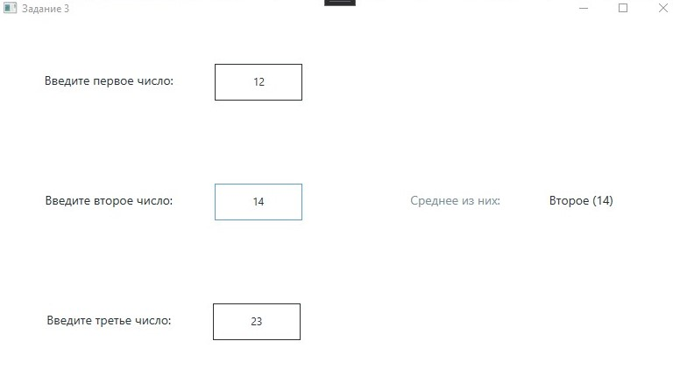

**Задание 4**

Составить программу вычисления значения функции.

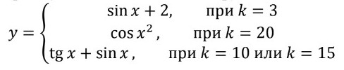

В остальных случаях значение y не определено.

**Листинг интерфейса.**

<Window x:Class="_4.MainWindow"

xmlns="http://schemas.microsoft.com/winfx/2006/xaml/presentation"

xmlns:x="http://schemas.microsoft.com/winfx/2006/xaml"

xmlns:d="http://schemas.microsoft.com/expression/blend/2008"

xmlns:mc="http://schemas.openxmlformats.org/markup-compatibility/2006"

xmlns:local="clr-namespace:_4"

mc:Ignorable="d"

Title="Задание 4" Height="450" Width="800">

<Window.Resources>

<Style TargetType="Control" x:Key="Graphic Element">

<Setter Property="Height" Value="42" />

<Setter Property="Margin" Value="16" />

<Setter Property="Padding" Value="12" />

</Style>

<Style TargetType="Label" x:Key="Text" BasedOn="{StaticResource Graphic Element}">

<Setter Property="FontSize" Value="14" />

<Setter Property="FontFamily" Value="Candana" />

</Style>

<Style x:Key="Main Text" TargetType="Label" BasedOn="{StaticResource Text}">

<Setter Property="Foreground" Value="#243238"/>

</Style>

<Style x:Key="Sub Text" TargetType="Label" BasedOn="{StaticResource Text}">

<Setter Property="Foreground" Value="#78909c"/>

</Style>

<Style x:Key="Attention Text" TargetType="Label" BasedOn="{StaticResource Text}">

<Setter Property="Foreground" Value="#fff6a5"/>

</Style>

<Style x:Key="TextBox" TargetType="TextBox" BasedOn="{StaticResource Graphic Element}">

<Setter Property="BorderBrush" Value="#243238"/>

<Setter Property="BorderThickness" Value="1"/>

<Setter Property="Foreground" Value="#243238"/>

<Setter Property="Width" Value="100"/>

<Setter Property="TextAlignment" Value="Center"/>

</Style>

</Window.Resources>

<Grid>

<Grid.RowDefinitions>

<RowDefinition></RowDefinition>

<RowDefinition></RowDefinition>

</Grid.RowDefinitions>

<Grid.ColumnDefinitions>

<ColumnDefinition></ColumnDefinition>

<ColumnDefinition></ColumnDefinition>

</Grid.ColumnDefinitions>

<StackPanel Grid.Row="0" Grid.Column="0" Orientation="Horizontal" HorizontalAlignment="Center" VerticalAlignment="Center">

<Label Content="Введите x: " Style="{StaticResource Main Text}"></Label>

<TextBox x:Name="X" Style="{StaticResource TextBox}" TextChanged="X_TextChanged"></TextBox>

</StackPanel>

<StackPanel Grid.Row="0" Grid.Column="2" Orientation="Horizontal" HorizontalAlignment="Center" VerticalAlignment="Center">

<Label Content="Введите k: " Style="{StaticResource Main Text}"></Label>

<TextBox x:Name="K" Style="{StaticResource TextBox}" TextChanged="K_TextChanged"></TextBox>

</StackPanel>

<StackPanel Grid.Row="1" Grid.Column="0" Grid.ColumnSpan="2" Grid.RowSpan="2" Orientation="Vertical" HorizontalAlignment="Center" VerticalAlignment="Center">

<StackPanel Orientation="Horizontal" HorizontalAlignment="Center" VerticalAlignment="Center">

<Label Content="Y:" Style="{StaticResource Sub Text}"></Label>

<Label x:Name="Y" Style="{StaticResource Main Text}">-</Label>

</StackPanel>

</StackPanel>

</Grid>

</Window>

**Листинг программы.**

using System;

using System.Collections.Generic;

using System.Linq;

using System.Text;

using System.Threading.Tasks;

using System.Windows;

using System.Windows.Controls;

using System.Windows.Data;

using System.Windows.Documents;

using System.Windows.Input;

using System.Windows.Media;

using System.Windows.Media.Imaging;

using System.Windows.Navigation;

using System.Windows.Shapes;

namespace _4

{

/// <summary>

/// Логика взаимодействия для MainWindow.xaml

/// </summary>

public partial class MainWindow : Window

{

public MainWindow()

{

InitializeComponent();

}

private void compute()

{

try

{

double x = double.Parse(X.Text);

double k = double.Parse(K.Text);

if (k == 3)

{

Y.Content = $"{Math.Sin(x) + 2}";

}

else if (k == 20)

{

Y.Content = $"{Math.Cos(Math.Pow(x, 2))}";

}

else if (k == 10 || k == 15)

{

Y.Content = $"{Math.Tan(x) + Math.Sin(x)}";

}

else

{

Y.Content = "Не определён";

}

}

catch

{

Y.Content = "-";

}

}

private void X_TextChanged(object sender, TextChangedEventArgs e)

{

compute();

}

private void K_TextChanged(object sender, TextChangedEventArgs e)

{

compute();

}

}

}

**Скриншот программы**

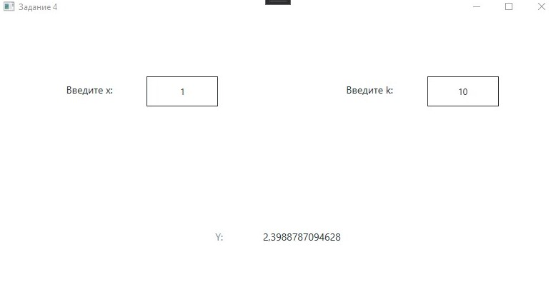

**Задание 5**

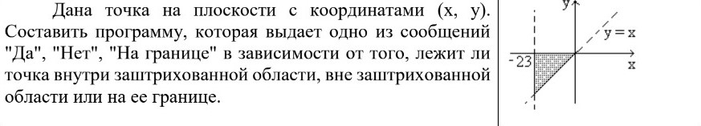

**Листинг интерфейса.**

<Window x:Class="_5.MainWindow"

xmlns="http://schemas.microsoft.com/winfx/2006/xaml/presentation"

xmlns:x="http://schemas.microsoft.com/winfx/2006/xaml"

xmlns:d="http://schemas.microsoft.com/expression/blend/2008"

xmlns:mc="http://schemas.openxmlformats.org/markup-compatibility/2006"

xmlns:local="clr-namespace:_5"

mc:Ignorable="d"

Title="Задание 5" Height="450" Width="800">

<Window.Resources>

<Style TargetType="Control" x:Key="Graphic Element">

<Setter Property="Height" Value="42" />

<Setter Property="Margin" Value="16" />

<Setter Property="Padding" Value="12" />

</Style>

<Style TargetType="Label" x:Key="Text" BasedOn="{StaticResource Graphic Element}">

<Setter Property="FontSize" Value="14" />

<Setter Property="FontFamily" Value="Candana" />

</Style>

<Style x:Key="Main Text" TargetType="Label" BasedOn="{StaticResource Text}">

<Setter Property="Foreground" Value="#243238"/>

</Style>

<Style x:Key="Sub Text" TargetType="Label" BasedOn="{StaticResource Text}">

<Setter Property="Foreground" Value="#78909c"/>

</Style>

<Style x:Key="Attention Text" TargetType="Label" BasedOn="{StaticResource Text}">

<Setter Property="Foreground" Value="#fff6a5"/>

</Style>

<Style x:Key="TextBox" TargetType="TextBox" BasedOn="{StaticResource Graphic Element}">

<Setter Property="BorderBrush" Value="#243238"/>

<Setter Property="BorderThickness" Value="1"/>

<Setter Property="Foreground" Value="#243238"/>

<Setter Property="Width" Value="100"/>

<Setter Property="TextAlignment" Value="Center"/>

</Style>

</Window.Resources>

<Grid>

<Grid.RowDefinitions>

<RowDefinition></RowDefinition>

<RowDefinition></RowDefinition>

</Grid.RowDefinitions>

<Grid.ColumnDefinitions>

<ColumnDefinition></ColumnDefinition>

<ColumnDefinition></ColumnDefinition>

</Grid.ColumnDefinitions>

<StackPanel Grid.Row="0" Grid.Column="0" Orientation="Horizontal" HorizontalAlignment="Center" VerticalAlignment="Center">

<Label Content="Введите x: " Style="{StaticResource Main Text}"></Label>

<TextBox x:Name="X" Style="{StaticResource TextBox}" TextChanged="X_TextChanged"></TextBox>

</StackPanel>

<StackPanel Grid.Row="0" Grid.Column="2" Orientation="Horizontal" HorizontalAlignment="Center" VerticalAlignment="Center">

<Label Content="Введите y: " Style="{StaticResource Main Text}"></Label>

<TextBox x:Name="Y" Style="{StaticResource TextBox}" TextChanged="Y_TextChanged"></TextBox>

</StackPanel>

<StackPanel Grid.Row="1" Grid.Column="0" Grid.ColumnSpan="2" Grid.RowSpan="2" Orientation="Vertical" HorizontalAlignment="Center" VerticalAlignment="Center">

<StackPanel Orientation="Horizontal" HorizontalAlignment="Center" VerticalAlignment="Center">

<Label Content="Входит в область:" Style="{StaticResource Sub Text}"></Label>

<Label x:Name="Result" Style="{StaticResource Main Text}">-</Label>

</StackPanel>

</StackPanel>

</Grid>

</Window>

**Листинг программы.**

using System;

using System.Collections.Generic;

using System.Linq;

using System.Text;

using System.Threading.Tasks;

using System.Windows;

using System.Windows.Controls;

using System.Windows.Data;

using System.Windows.Documents;

using System.Windows.Input;

using System.Windows.Media;

using System.Windows.Media.Imaging;

using System.Windows.Navigation;

using System.Windows.Shapes;

namespace _5

{

/// <summary>

/// Логика взаимодействия для MainWindow.xaml

/// </summary>

public partial class MainWindow : Window

{

public MainWindow()

{

InitializeComponent();

}

private void compute()

{

try

{

double x = double.Parse(X.Text);

double y = double.Parse(Y.Text);

if (x > -23 && y > x && y < 0)

{

Result.Content = "Да";

}

else if ((x == -23 && y >= x && y <= 0) || (x >= -23 && y == x && y <= 0) || (x >= -23 && y >= x && y == 0))

{

Result.Content = "На границе";

}

else

{

Result.Content = "Нет";

}

}

catch

{

Result.Content = "-";

}

}

private void Y_TextChanged(object sender, TextChangedEventArgs e)

{

compute();

}

private void X_TextChanged(object sender, TextChangedEventArgs e)

{

compute();

}

}

}

**Скриншот программы**

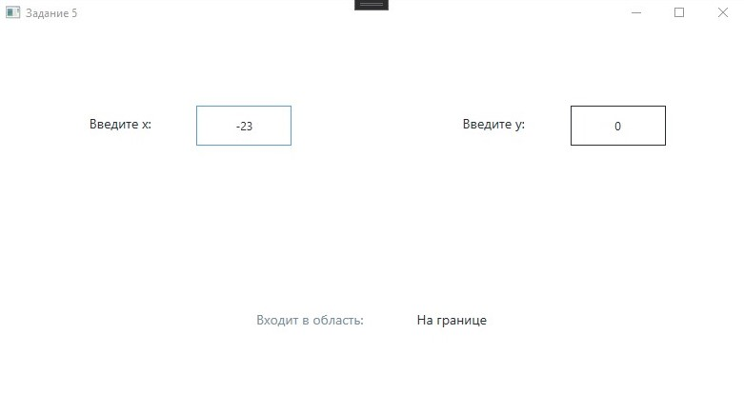

**Задание 6**

Дано целое число. Вывести его строку-описание вида «отрицательное четное

число», «нулевое число», «положительное нечетное число» и т. д.

**Листинг интерфейса.**

<Window x:Class="_6.MainWindow"

xmlns="http://schemas.microsoft.com/winfx/2006/xaml/presentation"

xmlns:x="http://schemas.microsoft.com/winfx/2006/xaml"

xmlns:d="http://schemas.microsoft.com/expression/blend/2008"

xmlns:mc="http://schemas.openxmlformats.org/markup-compatibility/2006"

xmlns:local="clr-namespace:_6"

mc:Ignorable="d"

Title="Задание 6" Height="450" Width="800">

<Window.Resources>

<Style TargetType="Control" x:Key="Graphic Element">

<Setter Property="Height" Value="42" />

<Setter Property="Margin" Value="16" />

<Setter Property="Padding" Value="12" />

</Style>

<Style TargetType="Label" x:Key="Text" BasedOn="{StaticResource Graphic Element}">

<Setter Property="FontSize" Value="14" />

<Setter Property="FontFamily" Value="Candana" />

</Style>

<Style x:Key="Main Text" TargetType="Label" BasedOn="{StaticResource Text}">

<Setter Property="Foreground" Value="#243238"/>

</Style>

<Style x:Key="Sub Text" TargetType="Label" BasedOn="{StaticResource Text}">

<Setter Property="Foreground" Value="#78909c"/>

</Style>

<Style x:Key="Attention Text" TargetType="Label" BasedOn="{StaticResource Text}">

<Setter Property="Foreground" Value="#fff6a5"/>

</Style>

<Style x:Key="TextBox" TargetType="TextBox" BasedOn="{StaticResource Graphic Element}">

<Setter Property="BorderBrush" Value="#243238"/>

<Setter Property="BorderThickness" Value="1"/>

<Setter Property="Foreground" Value="#243238"/>

<Setter Property="Width" Value="100"/>

<Setter Property="TextAlignment" Value="Center"/>

</Style>

</Window.Resources>

<Grid>

<Grid.RowDefinitions>

<RowDefinition></RowDefinition>

<RowDefinition></RowDefinition>

<RowDefinition></RowDefinition>

<RowDefinition></RowDefinition>

</Grid.RowDefinitions>

<Grid.ColumnDefinitions>

<ColumnDefinition></ColumnDefinition>

</Grid.ColumnDefinitions>

<StackPanel Grid.Row="0" Grid.RowSpan="2" Orientation="Horizontal" HorizontalAlignment="Center" VerticalAlignment="Center">

<Label Content="Введите целое число: " Style="{StaticResource Main Text}"></Label>

<TextBox x:Name="Number" Style="{StaticResource TextBox}" TextChanged="Number_TextChanged"></TextBox>

</StackPanel>

<StackPanel Grid.Row="2" Grid.RowSpan="2" Orientation="Vertical" HorizontalAlignment="Center" VerticalAlignment="Center">

<StackPanel Orientation="Horizontal" HorizontalAlignment="Center" VerticalAlignment="Center">

<Label Content="Описание:" Style="{StaticResource Sub Text}"></Label>

<Label x:Name="Result" Style="{StaticResource Main Text}">-</Label>

</StackPanel>

</StackPanel>

</Grid>

</Window>

**Листинг программы.**

using System;

using System.Collections.Generic;

using System.Linq;

using System.Text;

using System.Threading.Tasks;

using System.Windows;

using System.Windows.Controls;

using System.Windows.Data;

using System.Windows.Documents;

using System.Windows.Input;

using System.Windows.Media;

using System.Windows.Media.Imaging;

using System.Windows.Navigation;

using System.Windows.Shapes;

namespace _6

{

/// <summary>

/// Логика взаимодействия для MainWindow.xaml

/// </summary>

public partial class MainWindow : Window

{

public MainWindow()

{

InitializeComponent();

}

private void compute()

{

try

{

int number = int.Parse(Number.Text);

string result = "";

if (number == 0)

{

Result.Content = "Нулевое число";

}

else

{

if (number > 0)

{

result += "Положительное ";

}

else

{

result += "Отрицательное ";

}

if (number % 2 == 0)

{

result += "чётное";

}

else

{

result += "нечётное";

}

Result.Content = $"{result} число";

}

}

catch

{

Result.Content = "-";

}

}

private void Number_TextChanged(object sender, TextChangedEventArgs e)

{

compute();

}

}

}

**Скриншот программы**

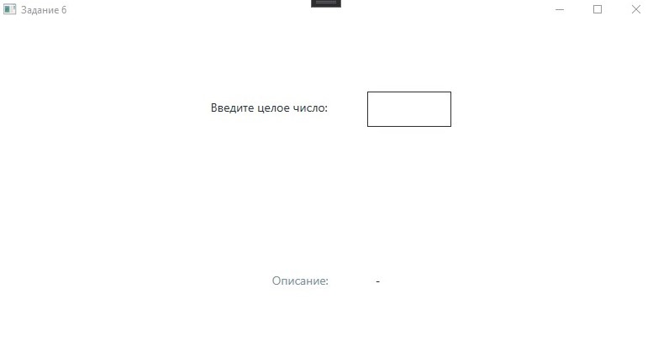

**Задание 7**

Дано целое число, лежащее в диапазоне 1–999. Вывести его строку-описание вида

«четное двузначное число», «нечетное трехзначное число» и т. д.

**Листинг интерфейса.**

<Window x:Class="_7.MainWindow"

xmlns="http://schemas.microsoft.com/winfx/2006/xaml/presentation"

xmlns:x="http://schemas.microsoft.com/winfx/2006/xaml"

xmlns:d="http://schemas.microsoft.com/expression/blend/2008"

xmlns:mc="http://schemas.openxmlformats.org/markup-compatibility/2006"

xmlns:local="clr-namespace:_7"

mc:Ignorable="d"

Title="Задание 7" Height="450" Width="800">

<Window.Resources>

<Style TargetType="Control" x:Key="Graphic Element">

<Setter Property="Height" Value="42" />

<Setter Property="Margin" Value="16" />

<Setter Property="Padding" Value="12" />

</Style>

<Style TargetType="Label" x:Key="Text" BasedOn="{StaticResource Graphic Element}">

<Setter Property="FontSize" Value="14" />

<Setter Property="FontFamily" Value="Candana" />

</Style>

<Style x:Key="Main Text" TargetType="Label" BasedOn="{StaticResource Text}">

<Setter Property="Foreground" Value="#243238"/>

</Style>

<Style x:Key="Sub Text" TargetType="Label" BasedOn="{StaticResource Text}">

<Setter Property="Foreground" Value="#78909c"/>

</Style>

<Style x:Key="Attention Text" TargetType="Label" BasedOn="{StaticResource Text}">

<Setter Property="Foreground" Value="#fff6a5"/>

</Style>

<Style x:Key="TextBox" TargetType="TextBox" BasedOn="{StaticResource Graphic Element}">

<Setter Property="BorderBrush" Value="#243238"/>

<Setter Property="BorderThickness" Value="1"/>

<Setter Property="Foreground" Value="#243238"/>

<Setter Property="Width" Value="100"/>

<Setter Property="TextAlignment" Value="Center"/>

</Style>

</Window.Resources>

<Grid>

<Grid.RowDefinitions>

<RowDefinition></RowDefinition>

<RowDefinition></RowDefinition>

<RowDefinition></RowDefinition>

<RowDefinition></RowDefinition>

</Grid.RowDefinitions>

<Grid.ColumnDefinitions>

<ColumnDefinition></ColumnDefinition>

</Grid.ColumnDefinitions>

<StackPanel Grid.Row="0" Grid.RowSpan="2" Orientation="Horizontal" HorizontalAlignment="Center" VerticalAlignment="Center">

<Label Content="Введите целое число: " Style="{StaticResource Main Text}"></Label>

<TextBox x:Name="Number" Style="{StaticResource TextBox}" TextChanged="Number_TextChanged"></TextBox>

</StackPanel>

<StackPanel Grid.Row="2" Grid.RowSpan="2" Orientation="Vertical" HorizontalAlignment="Center" VerticalAlignment="Center">

<StackPanel Orientation="Horizontal" HorizontalAlignment="Center" VerticalAlignment="Center">

<Label Content="Описание:" Style="{StaticResource Sub Text}"></Label>

<Label x:Name="Result" Style="{StaticResource Main Text}">-</Label>

</StackPanel>

</StackPanel>

</Grid>

</Window>

**Листинг программы.**

using System;

using System.Collections.Generic;

using System.Linq;

using System.Text;

using System.Threading.Tasks;

using System.Windows;

using System.Windows.Controls;

using System.Windows.Data;

using System.Windows.Documents;

using System.Windows.Input;

using System.Windows.Media;

using System.Windows.Media.Imaging;

using System.Windows.Navigation;

using System.Windows.Shapes;

namespace _7

{

/// <summary>

/// Логика взаимодействия для MainWindow.xaml

/// </summary>

public partial class MainWindow : Window

{

public MainWindow()

{

InitializeComponent();

}

private void compute()

{

try

{

int number = int.Parse(Number.Text);

string result = "";

if (!(1 <= number && number <= 999))

{

throw new ArgumentOutOfRangeException();

}

else

{

if (number % 2 == 0)

{

result += "Чётное ";

}

else

{

result += "Нечётное ";

}

if ($"{number}".Length == 1)

{

result += "однозначное";

}

else if ($"{number}".Length == 2)

{

result += "двузначное";

}

else if ($"{number}".Length == 3)

{

result += "трёхзначное";

}

Result.Content = $"{result} число";

}

}

catch

{

Result.Content = "-";

}

}

private void Number_TextChanged(object sender, TextChangedEventArgs e)

{

compute();

}

}

}

**Скриншот программы**

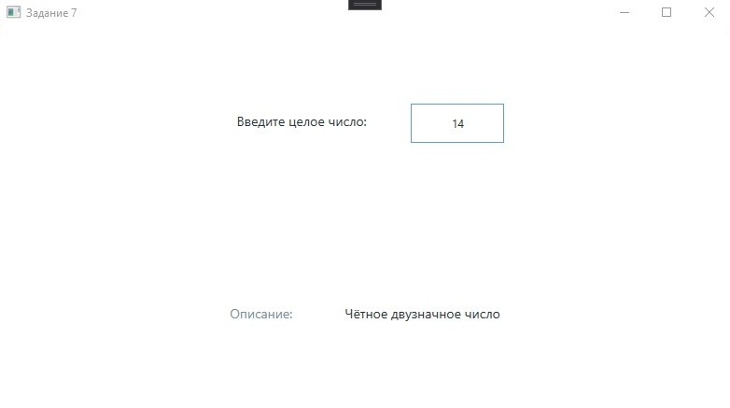

**ПР 04**

**Задание 1**

Единицы массы пронумерованы следующим образом: 1 — килограмм, 2 — миллиграмм, 3 — грамм, 4 — тонна, 5 — центнер. Дан номер единицы массы (целое число в диапазоне 1–5) и масса тела в этих единицах (вещественное число). Найти массу тела в килограммах.

**Листинг интерфейса.**

<Window x:Class="kochergin_225_4.MainWindow"

xmlns="http://schemas.microsoft.com/winfx/2006/xaml/presentation"

xmlns:x="http://schemas.microsoft.com/winfx/2006/xaml"

xmlns:d="http://schemas.microsoft.com/expression/blend/2008"

xmlns:mc="http://schemas.openxmlformats.org/markup-compatibility/2006"

xmlns:local="clr-namespace:kochergin_225_4"

mc:Ignorable="d"

Title="Задание 1" Height="450" Width="800">

<Window.Resources>

<Style TargetType="Control" x:Key="Graphic Element">

<Setter Property="Height" Value="42" />

<Setter Property="Margin" Value="16" />

<Setter Property="Padding" Value="12" />

</Style>

<Style TargetType="Label" x:Key="Text" BasedOn="{StaticResource Graphic Element}">

<Setter Property="FontSize" Value="14" />

<Setter Property="FontFamily" Value="Candana" />

</Style>

<Style x:Key="Main Text" TargetType="Label" BasedOn="{StaticResource Text}">

<Setter Property="Foreground" Value="#243238"/>

</Style>

<Style x:Key="Sub Text" TargetType="Label" BasedOn="{StaticResource Text}">

<Setter Property="Foreground" Value="#78909c"/>

</Style>

<Style x:Key="Attention Text" TargetType="Label" BasedOn="{StaticResource Text}">

<Setter Property="Foreground" Value="#fff6a5"/>

</Style>

<Style x:Key="TextBox" TargetType="TextBox" BasedOn="{StaticResource Graphic Element}">

<Setter Property="BorderBrush" Value="#243238"/>

<Setter Property="BorderThickness" Value="1"/>

<Setter Property="Foreground" Value="#243238"/>

<Setter Property="Width" Value="100"/>

<Setter Property="TextAlignment" Value="Center"/>

</Style>

</Window.Resources>

<Grid>

<Grid.RowDefinitions>

<RowDefinition></RowDefinition>

<RowDefinition></RowDefinition>

</Grid.RowDefinitions>

<Grid.ColumnDefinitions>

<ColumnDefinition></ColumnDefinition>

<ColumnDefinition></ColumnDefinition>

</Grid.ColumnDefinitions>

<StackPanel Grid.Row="0" Grid.Column="0" Orientation="Horizontal" HorizontalAlignment="Center" VerticalAlignment="Center">

<Label Content="Номер единицы массы: " Style="{StaticResource Main Text}"></Label>

<TextBox x:Name="First" Style="{StaticResource TextBox}" TextChanged="First_TextChanged"></TextBox>

</StackPanel>

<StackPanel Grid.Row="0" Grid.Column="2" Orientation="Horizontal" HorizontalAlignment="Center" VerticalAlignment="Center">

<Label Content="Масса тела: " Style="{StaticResource Main Text}"></Label>

<TextBox x:Name="Second" Style="{StaticResource TextBox}" TextChanged="Second_TextChanged"></TextBox>

</StackPanel>

<StackPanel Grid.Row="1" Grid.Column="0" Grid.ColumnSpan="2" Grid.RowSpan="2" Orientation="Vertical" HorizontalAlignment="Center" VerticalAlignment="Center">

<StackPanel Orientation="Horizontal" HorizontalAlignment="Center" VerticalAlignment="Center">

<Label Content="В килограммах:" Style="{StaticResource Sub Text}"></Label>

<Label x:Name="Result" Style="{StaticResource Main Text}">-</Label>

</StackPanel>

</StackPanel>

</Grid>

</Window>

**Листинг программы.**

using System;

using System.Collections.Generic;

using System.Linq;

using System.Text;

using System.Text.RegularExpressions;

using System.Threading.Tasks;

using System.Windows;

using System.Windows.Controls;

using System.Windows.Data;

using System.Windows.Documents;

using System.Windows.Input;

using System.Windows.Media;

using System.Windows.Media.Imaging;

using System.Windows.Navigation;

using System.Windows.Shapes;

namespace kochergin_225_4

{

/// <summary>

/// Interaction logic for MainWindow.xaml

/// </summary>

public partial class MainWindow : Window

{

public MainWindow()

{

InitializeComponent();

}

private void compute()

{

try

{

int index = int.Parse(First.Text);

string text = Second.Text;

string pattern = @",";

string target = ".";

Regex regex = new Regex(pattern);

string result = regex.Replace(text, target);

double weight = double.Parse(result);

switch (index)

{

// килограмм

case 1:

Result.Content = $"{Math.Round(weight, 6)}";

break;

// миллиграмм

case 2:

Result.Content = $"{Math.Round(0.000001 * weight, 9)}";

break;

// грамм

case 3:

Result.Content = $"{Math.Round(0.001 * weight, 6)}";

break;

// тонна

case 4:

Result.Content = $"{Math.Round(1000 * weight, 6)}";

break;

// центнер

case 5:

Result.Content = $"{Math.Round(100 * weight, 6)}";

break;

default:

Result.Content = "-";

break;

}

}

catch

{

Result.Content = "-";

}

}

private void First_TextChanged(object sender, TextChangedEventArgs e)

{

compute();

}

private void Second_TextChanged(object sender, TextChangedEventArgs e)

{

compute();

}

}

}

**Скриншот программы**

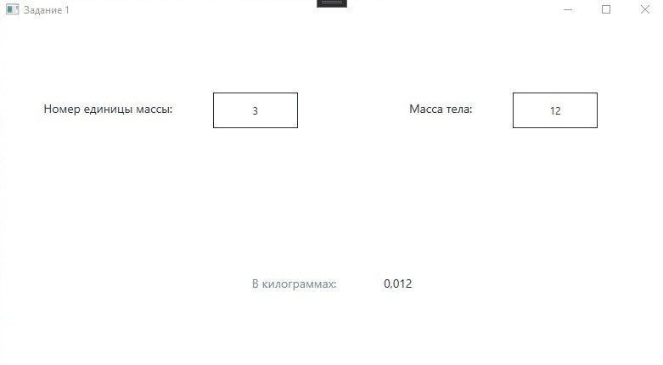

**Задание 2**

Мастям игральных карт присвоены порядковые номера: 1 — пики, 2 — трефы, 3 — бубны, 4 — червы. Достоинству карт, старших десятки, присвоены номера: 11 — валет, 12 — дама, 13 — король, 14 — туз. Даны два целых числа: N — достоинство (6≤N≤14) и M — масть карты (1≤M≤4). Вывести название соответствующей карты вида «шестерка бубен», «дама червей», «туз треф» и т.д.

**Листинг интерфейса.**

<Window x:Class="_2.MainWindow"

xmlns="http://schemas.microsoft.com/winfx/2006/xaml/presentation"

xmlns:x="http://schemas.microsoft.com/winfx/2006/xaml"

xmlns:d="http://schemas.microsoft.com/expression/blend/2008"

xmlns:mc="http://schemas.openxmlformats.org/markup-compatibility/2006"

xmlns:local="clr-namespace:_2"

mc:Ignorable="d"

Title="Задание 2" Height="450" Width="800">

<Window.Resources>

<Style TargetType="Control" x:Key="Graphic Element">

<Setter Property="Height" Value="42" />

<Setter Property="Margin" Value="16" />

<Setter Property="Padding" Value="12" />

</Style>

<Style TargetType="Label" x:Key="Text" BasedOn="{StaticResource Graphic Element}">

<Setter Property="FontSize" Value="14" />

<Setter Property="FontFamily" Value="Candana" />

</Style>

<Style x:Key="Main Text" TargetType="Label" BasedOn="{StaticResource Text}">

<Setter Property="Foreground" Value="#243238"/>

</Style>

<Style x:Key="Sub Text" TargetType="Label" BasedOn="{StaticResource Text}">

<Setter Property="Foreground" Value="#78909c"/>

</Style>

<Style x:Key="Attention Text" TargetType="Label" BasedOn="{StaticResource Text}">

<Setter Property="Foreground" Value="#fff6a5"/>

</Style>

<Style x:Key="TextBox" TargetType="TextBox" BasedOn="{StaticResource Graphic Element}">

<Setter Property="BorderBrush" Value="#243238"/>

<Setter Property="BorderThickness" Value="1"/>

<Setter Property="Foreground" Value="#243238"/>

<Setter Property="Width" Value="100"/>

<Setter Property="TextAlignment" Value="Center"/>

</Style>

</Window.Resources>

<Grid>

<Grid.RowDefinitions>

<RowDefinition></RowDefinition>

<RowDefinition></RowDefinition>

</Grid.RowDefinitions>

<Grid.ColumnDefinitions>

<ColumnDefinition></ColumnDefinition>

<ColumnDefinition></ColumnDefinition>

</Grid.ColumnDefinitions>

<StackPanel Grid.Row="0" Grid.Column="0" Orientation="Horizontal" HorizontalAlignment="Center" VerticalAlignment="Center">

<Label Content="Введите M: " Style="{StaticResource Main Text}"></Label>

<TextBox x:Name="M" Style="{StaticResource TextBox}" TextChanged="M_TextChanged"></TextBox>

</StackPanel>

<StackPanel Grid.Row="0" Grid.Column="2" Orientation="Horizontal" HorizontalAlignment="Center" VerticalAlignment="Center">

<Label Content="Введите N: " Style="{StaticResource Main Text}"></Label>

<TextBox x:Name="N" Style="{StaticResource TextBox}" TextChanged="N_TextChanged"></TextBox>

</StackPanel>

<StackPanel Grid.Row="1" Grid.Column="0" Grid.ColumnSpan="2" Grid.RowSpan="2" Orientation="Vertical" HorizontalAlignment="Center" VerticalAlignment="Center">

<StackPanel Orientation="Horizontal" HorizontalAlignment="Center" VerticalAlignment="Center">

<Label Content="Название:" Style="{StaticResource Sub Text}"></Label>

<Label x:Name="Result" Style="{StaticResource Main Text}">-</Label>

</StackPanel>

</StackPanel>

</Grid>

</Window>

**Листинг программы.**

using System;

using System.Collections.Generic;

using System.Linq;

using System.Text;

using System.Threading.Tasks;

using System.Windows;

using System.Windows.Controls;

using System.Windows.Data;

using System.Windows.Documents;

using System.Windows.Input;

using System.Windows.Media;

using System.Windows.Media.Imaging;

using System.Windows.Navigation;

using System.Windows.Shapes;

namespace _2

{

/// <summary>

/// Interaction logic for MainWindow.xaml

/// </summary>

public partial class MainWindow : Window

{

public MainWindow()

{

InitializeComponent();

}

private void compute()

{

try

{

int n = int.Parse(N.Text);

int m = int.Parse(M.Text);

string result = "";

switch (m)

{

case 6:

result += "Шестёрка";

break;

case 7:

result += "Семёрка";

break;

case 8:

result += "Восьмёрка";

break;

case 9:

result += "Девятка";

break;

case 10:

result += "Десятка";

break;

case 11:

result += "Валет";

break;

case 12:

result += "Дама";

break;

case 13:

result += "Король";

break;

case 14:

result += "Туз";

break;

default:

throw new ArgumentOutOfRangeException();

}

switch (n)

{

case 1:

result += " пики";

break;

case 2:

result += " треф";

break;

case 3:

result += " бубен";

break;

case 4:

result += " червей";

break;

default:

throw new ArgumentOutOfRangeException();

}

Result.Content = result;

}

catch

{

Result.Content = "-";

}

}

private void M_TextChanged(object sender, TextChangedEventArgs e)

{

compute();

}

private void N_TextChanged(object sender, TextChangedEventArgs e)

{

compute();

}

}

}

**Скриншот программы**

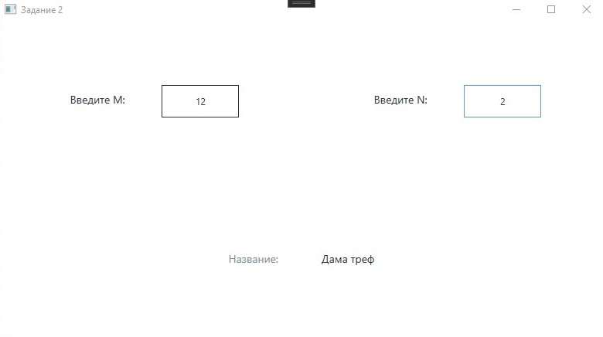

**Задание 3**

Элементы равнобедренного прямоугольного треугольника пронумерованы

следующим образом: 1 — катет a, 2 — гипотенуза c = a ∙ √2 , 3 — высота h,

опущенная на гипотенузу (h=c/2), 4 — площадь S = c ∙ h/2. Дан номер одного из этих элементов и его значение. Вывести значения остальных элементов данного треугольника (в том же порядке).

**Листинг интерфейса.**

<Window x:Class="_3.MainWindow"

xmlns="http://schemas.microsoft.com/winfx/2006/xaml/presentation"

xmlns:x="http://schemas.microsoft.com/winfx/2006/xaml"

xmlns:d="http://schemas.microsoft.com/expression/blend/2008"

xmlns:mc="http://schemas.openxmlformats.org/markup-compatibility/2006"

xmlns:local="clr-namespace:_3"

mc:Ignorable="d"

Title="Задание 3" Height="450" Width="800">

<Window.Resources>

<Style TargetType="Control" x:Key="Graphic Element">

<Setter Property="Height" Value="42" />

<Setter Property="Margin" Value="16" />

<Setter Property="Padding" Value="12" />

</Style>

<Style TargetType="Label" x:Key="Text" BasedOn="{StaticResource Graphic Element}">

<Setter Property="FontSize" Value="14" />

<Setter Property="FontFamily" Value="Candana" />

</Style>

<Style x:Key="Main Text" TargetType="Label" BasedOn="{StaticResource Text}">

<Setter Property="Foreground" Value="#243238"/>

</Style>

<Style x:Key="Sub Text" TargetType="Label" BasedOn="{StaticResource Text}">

<Setter Property="Foreground" Value="#78909c"/>

</Style>

<Style x:Key="Attention Text" TargetType="Label" BasedOn="{StaticResource Text}">

<Setter Property="Foreground" Value="#fff6a5"/>

</Style>

<Style x:Key="TextBox" TargetType="TextBox" BasedOn="{StaticResource Graphic Element}">

<Setter Property="BorderBrush" Value="#243238"/>

<Setter Property="BorderThickness" Value="1"/>

<Setter Property="Foreground" Value="#243238"/>

<Setter Property="Width" Value="100"/>

<Setter Property="TextAlignment" Value="Center"/>

</Style>

</Window.Resources>

<Grid>

<Grid.RowDefinitions>

<RowDefinition></RowDefinition>

<RowDefinition></RowDefinition>

</Grid.RowDefinitions>

<Grid.ColumnDefinitions>

<ColumnDefinition></ColumnDefinition>

<ColumnDefinition></ColumnDefinition>

</Grid.ColumnDefinitions>

<StackPanel Grid.Row="0" Grid.Column="0" Orientation="Horizontal" HorizontalAlignment="Center" VerticalAlignment="Center">

<Label Content="Номер: " Style="{StaticResource Main Text}"></Label>

<TextBox x:Name="Number" Style="{StaticResource TextBox}" TextChanged="Number_TextChanged"></TextBox>

</StackPanel>

<StackPanel Grid.Row="0" Grid.Column="2" Orientation="Horizontal" HorizontalAlignment="Center" VerticalAlignment="Center">

<Label Content="Значение: " Style="{StaticResource Main Text}"></Label>

<TextBox x:Name="Value" Style="{StaticResource TextBox}" TextChanged="Value_TextChanged"></TextBox>

</StackPanel>

<StackPanel Grid.Row="1" Grid.Column="0" Grid.ColumnSpan="2" Grid.RowSpan="2" Orientation="Vertical" HorizontalAlignment="Center" VerticalAlignment="Center">

<StackPanel Orientation="Horizontal" HorizontalAlignment="Center" VerticalAlignment="Center">

<Label Content="Остальные значения:" Style="{StaticResource Sub Text}"></Label>

<Label x:Name="Result" Style="{StaticResource Main Text}">-</Label>

</StackPanel>

</StackPanel>

</Grid>

</Window>

**Листинг программы.**

using System;

using System.Collections.Generic;

using System.Linq;

using System.Text;

using System.Threading.Tasks;

using System.Windows;

using System.Windows.Controls;

using System.Windows.Data;

using System.Windows.Documents;

using System.Windows.Input;

using System.Windows.Media;

using System.Windows.Media.Imaging;

using System.Windows.Navigation;

using System.Windows.Shapes;

namespace _3

{

/// <summary>

/// Interaction logic for MainWindow.xaml

/// </summary>

public partial class MainWindow : Window

{

public MainWindow()

{

InitializeComponent();

}

private void compute()

{

try

{

int number = int.Parse(Number.Text);

double value = double.Parse(Value.Text);

string result = "";

// все параметры треугольника на плоскости в евклидовом пространстве, значит должны быть положительны

if (value > 0) { }

else { throw new ArgumentOutOfRangeException(); }

switch (number)

{

// val = a

case 1:

result += $"2 - {Math.Round(value * Math.Sqrt(2), 2)}; ";

result += $"3 - {Math.Round(value * Math.Sqrt(2) / 2.0, 2)}; ";

result += $"4 - {Math.Round(value * value, 2)}";

Result.Content = result;

break;

// val = c

case 2:

result += $"1 - {Math.Round(value * Math.Sqrt(2) / 2, 2)}; ";

result += $"3 - {Math.Round(value / 2, 2)}; ";

result += $"4 - {Math.Round(value * value / 2, 2)}";

Result.Content = result;

break;

// val = h

case 3:

result += $"1 - {Math.Round(value * Math.Sqrt(2), 2)}; ";

result += $"2 - {Math.Round(value * 2, 2)}; ";

result += $"4 - {Math.Round(value * value, 2)}";

Result.Content = result;

break;

// val = S

case 4:

result += $"1 - {Math.Round(Math.Sqrt(2 * value), 2)}; ";

result += $"2 - {Math.Round(2 * Math.Sqrt(value), 2)}; ";

result += $"3 - {Math.Round(Math.Sqrt(value), 2)}";

Result.Content = result;

break;

default:

throw new ArgumentOutOfRangeException();

}

}

catch

{

Result.Content = "-";

}

}

private void Value_TextChanged(object sender, TextChangedEventArgs e)

{

compute();

}

private void Number_TextChanged(object sender, TextChangedEventArgs e)

{

compute();

}

}

}

**Скриншот программы**

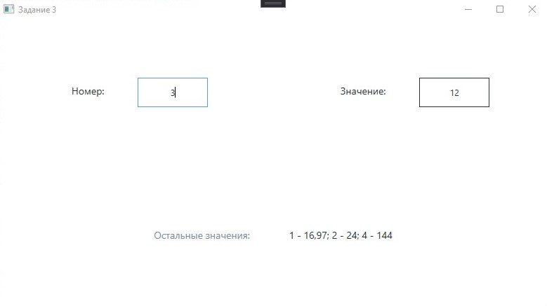

**Задание 4**

Дано целое число N (> 0). Найти наименьшее целое положительное число K,

квадрат которого превосходит N: K2 > N. Функцию извлечения квадратного корня не использовать.

**Листинг интерфейса.**

<Window x:Class="_4.MainWindow"

xmlns="http://schemas.microsoft.com/winfx/2006/xaml/presentation"

xmlns:x="http://schemas.microsoft.com/winfx/2006/xaml"

xmlns:d="http://schemas.microsoft.com/expression/blend/2008"

xmlns:mc="http://schemas.openxmlformats.org/markup-compatibility/2006"

xmlns:local="clr-namespace:_4"

mc:Ignorable="d"

Title="Задание 4" Height="450" Width="800">

<Window.Resources>

<Style TargetType="Control" x:Key="Graphic Element">

<Setter Property="Height" Value="42" />

<Setter Property="Margin" Value="16" />

<Setter Property="Padding" Value="12" />

</Style>

<Style TargetType="Label" x:Key="Text" BasedOn="{StaticResource Graphic Element}">

<Setter Property="FontSize" Value="14" />

<Setter Property="FontFamily" Value="Candana" />

</Style>

<Style x:Key="Main Text" TargetType="Label" BasedOn="{StaticResource Text}">

<Setter Property="Foreground" Value="#243238"/>

</Style>

<Style x:Key="Sub Text" TargetType="Label" BasedOn="{StaticResource Text}">

<Setter Property="Foreground" Value="#78909c"/>

</Style>

<Style x:Key="Attention Text" TargetType="Label" BasedOn="{StaticResource Text}">

<Setter Property="Foreground" Value="#fff6a5"/>

</Style>

<Style x:Key="TextBox" TargetType="TextBox" BasedOn="{StaticResource Graphic Element}">

<Setter Property="BorderBrush" Value="#243238"/>

<Setter Property="BorderThickness" Value="1"/>

<Setter Property="Foreground" Value="#243238"/>

<Setter Property="Width" Value="100"/>

<Setter Property="TextAlignment" Value="Center"/>

</Style>

</Window.Resources>

<Grid>

<Grid.RowDefinitions>

<RowDefinition></RowDefinition>

<RowDefinition></RowDefinition>

<RowDefinition></RowDefinition>

<RowDefinition></RowDefinition>

</Grid.RowDefinitions>

<Grid.ColumnDefinitions>

<ColumnDefinition></ColumnDefinition>

</Grid.ColumnDefinitions>

<StackPanel Grid.Row="0" Grid.RowSpan="2" Orientation="Horizontal" HorizontalAlignment="Center" VerticalAlignment="Center">

<Label Content="Введите целое число N: " Style="{StaticResource Main Text}"></Label>

<TextBox x:Name="N" Style="{StaticResource TextBox}" TextChanged="N_TextChanged"></TextBox>

</StackPanel>

<StackPanel Grid.Row="2" Grid.RowSpan="2" Orientation="Vertical" HorizontalAlignment="Center" VerticalAlignment="Center">

<StackPanel Orientation="Horizontal" HorizontalAlignment="Center" VerticalAlignment="Center">

<Label Content="Наименьшее, квадрат которого больше N:" Style="{StaticResource Sub Text}"></Label>

<Label x:Name="K" Style="{StaticResource Main Text}">-</Label>

</StackPanel>

</StackPanel>

</Grid>

</Window>

**Листинг программы.**

using System;

using System.Collections.Generic;

using System.Linq;

using System.Text;

using System.Threading.Tasks;

using System.Windows;

using System.Windows.Controls;

using System.Windows.Data;

using System.Windows.Documents;

using System.Windows.Input;

using System.Windows.Media;

using System.Windows.Media.Imaging;

using System.Windows.Navigation;

using System.Windows.Shapes;

namespace _4

{

/// <summary>

/// Interaction logic for MainWindow.xaml

/// </summary>

public partial class MainWindow : Window

{

public MainWindow()

{

InitializeComponent();

}

private void compute()

{

try

{

int n = int.Parse(N.Text);

if (n > 0) { }

else { throw new ArgumentOutOfRangeException(); }

int i = 1;

if (n == 1)

{

K.Content = "2";

}

else

{

do {

if (i * i > n)

{

K.Content = $"{i}";

break;

}

i++;

} while (i <= n);

}

}

catch

{

K.Content = "-";

}

}

private void N_TextChanged(object sender, TextChangedEventArgs e)

{

compute();

}

}

}

**Скриншот программы**

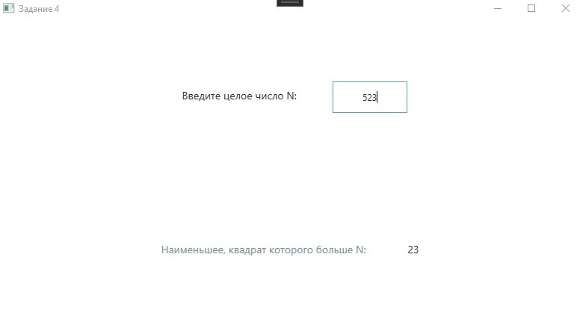

**Задание 5**

Спортсмен-лыжник начал тренировки, пробежав в первый день 10 км. Каждый

следующий день он увеличивал длину пробега на P процентов от пробега

предыдущего дня (P — вещественное, 0 < P < 50). По данному P определить, после какого дня суммарный пробег лыжника за все дни превысит 200 км, и вывести найденное количество дней K (целое) и суммарный пробег S (вещественное число).

**Листинг интерфейса.**

<Window x:Class="_5.MainWindow"

xmlns="http://schemas.microsoft.com/winfx/2006/xaml/presentation"

xmlns:x="http://schemas.microsoft.com/winfx/2006/xaml"

xmlns:d="http://schemas.microsoft.com/expression/blend/2008"

xmlns:mc="http://schemas.openxmlformats.org/markup-compatibility/2006"

xmlns:local="clr-namespace:_5"

mc:Ignorable="d"

Title="Задание 5" Height="450" Width="800">

<Window.Resources>

<Style TargetType="Control" x:Key="Graphic Element">

<Setter Property="Height" Value="42" />

<Setter Property="Margin" Value="16" />

<Setter Property="Padding" Value="12" />

</Style>

<Style TargetType="Label" x:Key="Text" BasedOn="{StaticResource Graphic Element}">

<Setter Property="FontSize" Value="14" />

<Setter Property="FontFamily" Value="Candana" />

</Style>

<Style x:Key="Main Text" TargetType="Label" BasedOn="{StaticResource Text}">

<Setter Property="Foreground" Value="#243238"/>

</Style>

<Style x:Key="Sub Text" TargetType="Label" BasedOn="{StaticResource Text}">

<Setter Property="Foreground" Value="#78909c"/>

</Style>

<Style x:Key="Attention Text" TargetType="Label" BasedOn="{StaticResource Text}">

<Setter Property="Foreground" Value="#fff6a5"/>

</Style>

<Style x:Key="TextBox" TargetType="TextBox" BasedOn="{StaticResource Graphic Element}">

<Setter Property="BorderBrush" Value="#243238"/>

<Setter Property="BorderThickness" Value="1"/>

<Setter Property="Foreground" Value="#243238"/>

<Setter Property="Width" Value="100"/>

<Setter Property="TextAlignment" Value="Center"/>

</Style>

</Window.Resources>

<Grid>

<Grid.RowDefinitions>

<RowDefinition></RowDefinition>

<RowDefinition></RowDefinition>

<RowDefinition></RowDefinition>

<RowDefinition></RowDefinition>

</Grid.RowDefinitions>

<Grid.ColumnDefinitions>

<ColumnDefinition></ColumnDefinition>

</Grid.ColumnDefinitions>

<StackPanel Grid.Row="0" Grid.RowSpan="2" Orientation="Horizontal" HorizontalAlignment="Center" VerticalAlignment="Center">

<Label Content="Введите число P: " Style="{StaticResource Main Text}"></Label>

<TextBox x:Name="P" Style="{StaticResource TextBox}" TextChanged="P_TextChanged"></TextBox>

</StackPanel>

<StackPanel Grid.Row="2" Grid.RowSpan="2" Orientation="Vertical" HorizontalAlignment="Center" VerticalAlignment="Center">

<StackPanel Orientation="Horizontal" HorizontalAlignment="Center" VerticalAlignment="Center">

<Label Content="После какого дня суммарно превысит 200км:" Style="{StaticResource Sub Text}"></Label>

<Label x:Name="K" Style="{StaticResource Main Text}">-</Label>

</StackPanel>

<StackPanel Orientation="Horizontal" HorizontalAlignment="Center" VerticalAlignment="Center">

<Label Content="Суммарный пробег:" Style="{StaticResource Sub Text}"></Label>

<Label x:Name="S" Style="{StaticResource Main Text}">-</Label>

</StackPanel>

</StackPanel>

</Grid>

</Window>

**Листинг программы.**

using System;

using System.Collections.Generic;

using System.Linq;

using System.Text;

using System.Threading.Tasks;

using System.Windows;

using System.Windows.Controls;

using System.Windows.Data;

using System.Windows.Documents;

using System.Windows.Input;

using System.Windows.Media;

using System.Windows.Media.Imaging;

using System.Windows.Navigation;

using System.Windows.Shapes;

namespace _5

{

/// <summary>

/// Interaction logic for MainWindow.xaml

/// </summary>

public partial class MainWindow : Window

{

public MainWindow()

{

InitializeComponent();

}

private void compute()

{

try

{

double p = double.Parse(P.Text);

if (0 < p && p < 50) { }

else { throw new ArgumentOutOfRangeException(); }

double q = 1 + p / 100;

double S_(int n)

{

return (10 * (1 - Math.Pow(q, n)) / (1 - q));

}

int k = 0;

for (int i = 1; S_(i) <= 200; i++)

{

k = i + 1;

}

K.Content = $"{k}";

S.Content = $"{S_(k + 1)}";

}

catch

{

K.Content = "-";

S.Content = "-";

}

}

private void P_TextChanged(object sender, TextChangedEventArgs e)

{

compute();

}

}

}

**Скриншот программы**

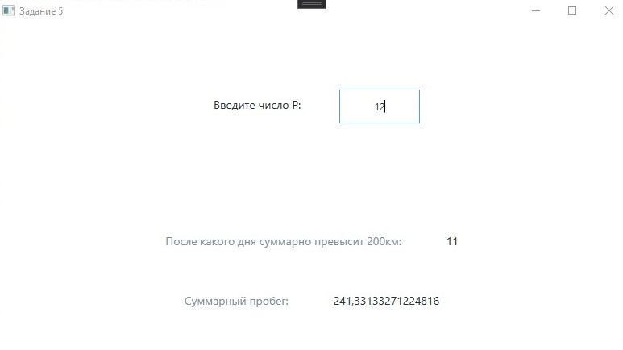

**Задание 6**

Дано целое число N (> 0). С помощью операций деления нацело и взятия остатка от деления определить, имеются ли в записи числа N четные цифры. Если имеются, то вывести true, если нет — вывести false.

**Листинг интерфейса.**

<Window x:Class="_6.MainWindow"

xmlns="http://schemas.microsoft.com/winfx/2006/xaml/presentation"

xmlns:x="http://schemas.microsoft.com/winfx/2006/xaml"

xmlns:d="http://schemas.microsoft.com/expression/blend/2008"

xmlns:mc="http://schemas.openxmlformats.org/markup-compatibility/2006"

xmlns:local="clr-namespace:_6"

mc:Ignorable="d"

Title="Задание 6" Height="450" Width="800">

<Window.Resources>

<Style TargetType="Control" x:Key="Graphic Element">

<Setter Property="Height" Value="42" />

<Setter Property="Margin" Value="16" />

<Setter Property="Padding" Value="12" />

</Style>

<Style TargetType="Label" x:Key="Text" BasedOn="{StaticResource Graphic Element}">

<Setter Property="FontSize" Value="14" />

<Setter Property="FontFamily" Value="Candana" />

</Style>

<Style x:Key="Main Text" TargetType="Label" BasedOn="{StaticResource Text}">

<Setter Property="Foreground" Value="#243238"/>

</Style>

<Style x:Key="Sub Text" TargetType="Label" BasedOn="{StaticResource Text}">

<Setter Property="Foreground" Value="#78909c"/>

</Style>

<Style x:Key="Attention Text" TargetType="Label" BasedOn="{StaticResource Text}">

<Setter Property="Foreground" Value="#fff6a5"/>

</Style>

<Style x:Key="TextBox" TargetType="TextBox" BasedOn="{StaticResource Graphic Element}">

<Setter Property="BorderBrush" Value="#243238"/>

<Setter Property="BorderThickness" Value="1"/>

<Setter Property="Foreground" Value="#243238"/>

<Setter Property="Width" Value="100"/>

<Setter Property="TextAlignment" Value="Center"/>

</Style>

</Window.Resources>

<Grid>

<Grid.RowDefinitions>

<RowDefinition></RowDefinition>

<RowDefinition></RowDefinition>

<RowDefinition></RowDefinition>

<RowDefinition></RowDefinition>

</Grid.RowDefinitions>

<Grid.ColumnDefinitions>

<ColumnDefinition></ColumnDefinition>

</Grid.ColumnDefinitions>

<StackPanel Grid.Row="0" Grid.RowSpan="2" Orientation="Horizontal" HorizontalAlignment="Center" VerticalAlignment="Center">

<Label Content="Введите целое число N: " Style="{StaticResource Main Text}"></Label>

<TextBox x:Name="N" Style="{StaticResource TextBox}" TextChanged="N_TextChanged"></TextBox>

</StackPanel>

<StackPanel Grid.Row="2" Grid.RowSpan="2" Orientation="Vertical" HorizontalAlignment="Center" VerticalAlignment="Center">

<StackPanel Orientation="Horizontal" HorizontalAlignment="Center" VerticalAlignment="Center">

<Label Content="Имеются ли четные цифры в записи:" Style="{StaticResource Sub Text}"></Label>

<Label x:Name="Result" Style="{StaticResource Main Text}">-</Label>

</StackPanel>

</StackPanel>

</Grid>

</Window>

**Листинг программы.**

using System;

using System.Collections.Generic;

using System.Linq;

using System.Text;

using System.Threading.Tasks;

using System.Windows;

using System.Windows.Controls;

using System.Windows.Data;

using System.Windows.Documents;

using System.Windows.Input;

using System.Windows.Media;

using System.Windows.Media.Imaging;

using System.Windows.Navigation;

using System.Windows.Shapes;

namespace _6

{

/// <summary>

/// Interaction logic for MainWindow.xaml

/// </summary>

public partial class MainWindow : Window

{

public MainWindow()

{

InitializeComponent();

}

private void compute()

{

try

{

int n = int.Parse(N.Text);

if (n > 0) { }

else { throw new ArgumentOutOfRangeException(); }

bool result = false;

foreach (char symbol in N.Text)

{

if (int.Parse($"{symbol}") % 2 == 0)

{

result = true;

}

}

Result.Content = $"{result}";

}

catch

{

Result.Content = "-";

}

}

private void N_TextChanged(object sender, TextChangedEventArgs e)

{

compute();

}

}

}

**Скриншот программы**

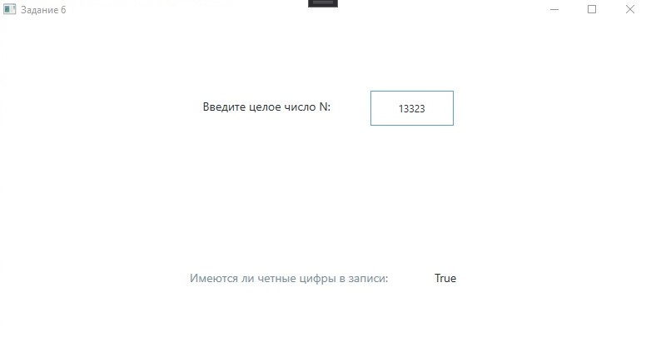

**ПР 05**

**Задание 1**

Напишите программу, которая в последовательности целых чисел определяет

количество чётных чисел, кратных 7. Программа получает на вход целые числа, количество введённых чисел неизвестно, последовательность чисел заканчивается числом 0 (0 – признак окончания ввода, не входит в последовательность). Количество чисел не превышает 1000. Введённые числа по модулю не превышают 30 000. Программа должна вывести одно число: количество чётных чисел, кратных 7.

**Листинг интерфейса.**

**Листинг программы.**

**Скриншот программы**

**Задание 2**

Напишите программу, которая в последовательности натуральных чисел определяет

сумму всех чисел, кратных 6 и оканчивающихся на 4. Программа получает на вход

натуральные числа, количество введённых чисел неизвестно, последовательность чисел

заканчивается числом 0 (0 – признак окончания ввода, не входит в последовательность).

Количество чисел не превышает 1000. Введённые числа не превышают 30 000.

Программа должна вывести одно число: сумму всех чисел, кратных 6 и

оканчивающихся на 4.

**Листинг интерфейса.**

**Листинг программы.**

**Скриншот программы**

**Задание 3**

**Листинг интерфейса.**

**Листинг программы.**

**Скриншот программы**

**Задание 4**

**Листинг интерфейса.**

**Листинг программы.**

**Скриншот программы**

**Задание 5**

**Листинг интерфейса.**

**Листинг программы.**

**Скриншот программы**